Staying Active at Home
Regular activity has many health and wellbeing benefits. Now, more than ever, it is important we keep active. Some of the benefits include:
- Reducing anxiety and depression
- Lifting mood
- Reducing the risk of some major age related diseases
- Improves balance and coordination, reducing the risk of falls
- Improves muscle strength and flexibility
- Helps maintain healthy bones and joints
- Helps reduce joint swelling and pain associated with arthritis
- Helps maintain independence
In this leaflet we have put together some simple exercises you can do at home. We have also included some useful information for websites and resources to help you keep active in your own home.

Quick Cuppa Workout
Some simple exercises to do while you wait for the kettle to boil.

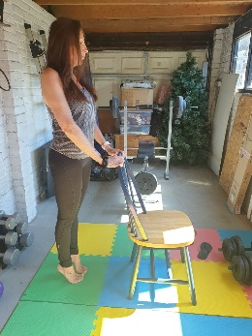
Exercise 1
- Hold onto worktop or chair.
- Face forward and slowly lift heels off the
floor so you are standing on your toes.
- Slowly lower heels back to the floor.
- Repeat 5 times

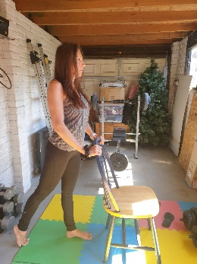
Exercise 2
- Hold onto worktop or chair.
- Face forward and slowly step backward with
one foot.
- Hold for the count of 3.
- Return to start position.
- Repeat 5 times on each leg.
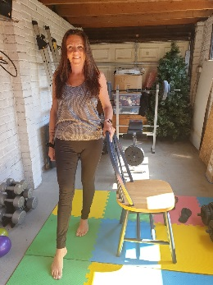
Exercise 3
- Hold onto worktop or chair.
- Face forward and slowly step forward with
one foot.
- Hold for the count of 3.
- Return to start position.
- Repeat 5 times on each leg
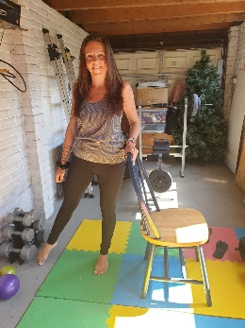
Exercise 4
- Hold onto worktop or chair.
- Face forward and slowly step to the side
with one foot.
- Hold for the count of 3.
- Return to start position.
- Repeat 5 times on each leg.
Exercise 5
- Hold onto worktop or chair.
- Slowly March on the spot for the count of 10.

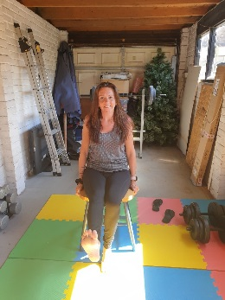
Armchair Activity
Exercise 1
- Sit upright, facing forward.
- Slowly lift one leg out in front of you, the return
to the floor
- Repeat 5 times on each leg

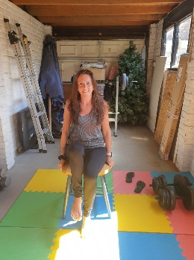
Exercise 2
- Sit upright, facing forward, knees bent.
- Keeping knee bent, slowly lift one leg up then
return to the floor.
- Repeat 5 times on each leg.

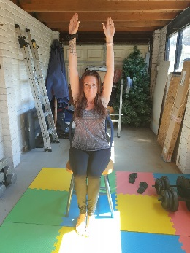
Exercise 3
- Face forward and slowly lift both arms above
your head.
- Hold for the count of 3.
- Return arms to your side.
- Repeat 5 times.

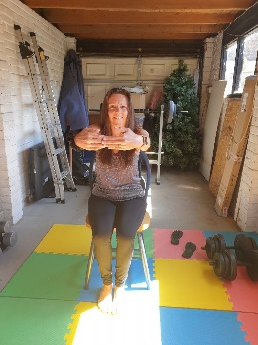
Exercise 4
- Facing forward, clasp hands together and stretch
out in front of you. Keep back upright and don’t
lean forward.
- Hold for the count of 3.
- Repeat 2 times.

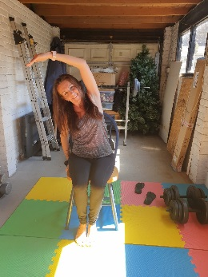
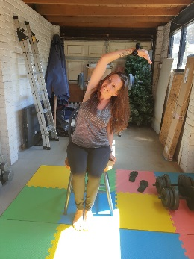
Exercise 5 & 6
- Facing forward, keep back upright,
lean over to your right
- Hold for the count of 3.
- Repeat on left side.

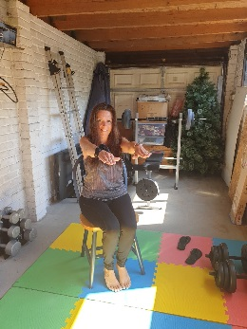
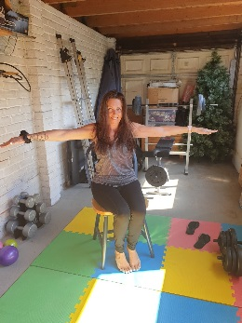
Exercise 7 & 8
- Facing forward, keep back upright,
lift arms out to the side.
- Hold for the count of 3.
- Facing forward, keep back upright,
lift arms out in front of you.
- Repeat 5 times.

Useful websites and resources

https://www.nhs.uk/live-well/exercise/exercise-health-benefits/
https://www.nhs.uk/live-well/exercise/physical-activity-guidelines-older-adults/
https://www.nhs.uk/live-well/exercise/sitting-exercises/
https://www.nhs.uk/live-well/exercise/balance-exercises/
https://www.activeessex.org/resource/activity-alliance-engagement-resources/
https://www.activeessex.org/
https://www.nhs.uk/live-well/exercise/exercise-as-you-get-older/
https://www.ageuk.org.uk/information-advice/health-wellbeing/exercise/simple-exercises-inactive-adults/
https://www.activeessex.org/wp-content/uploads/2020/04/15016-Strength-Balance-Booklet-Part-One-and-Two.pdf
https://www.activeessex.org/keep-essex-active/
https://www.activeessex.org/keep-essex-active-youtube/

DISCLAIMER

If you have any underlying conditions that may be affected by any of these activities, please consult you GP prior to participating in any exercise.

If during any of the activities you feel unwell, stop exercise immediately.

Taking part in any activity is at your own risk and Basildon Borough Council cannot be held responsible for any accident or injury as a result from taking part in these exercise.

