SPRING TERM HOME PE
Year 1
Turtle Travel crawling, changing direction skills
Equipment: Adult size sock filled with some children’s socks + 3 old T shirts

How to play:

Get started by filling up socks and then making sure they don’t spill out.

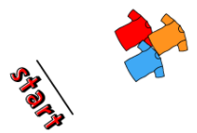

Lay out a t-shirt each on the floor, as this will be the “current”

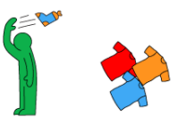

With your back to the “current”, throw your turtle over your shoulder, aiming
to land on the “current”.

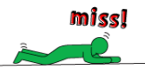
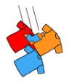
If you miss, you have to crawl on your hands and knees both ways to get it back.

Keep going until your turtle lands perfectly

How many times did it take to land your filled sock today? Try again another day and see if you can get better over the week.

Skill Tip: When you’re being a turtle, keep low to the ground, make sure your legs and arms work together to pull your body forwards. Try to keep your stomach flat and level to support your lower back.
Challenges:
- Play the game again, this time see how fast you crawl to the landing pad and back in full.
- Move the start line further away from the landing pad.
- Try throwing with your other hand. If you’re right handed try throwing with your left.

STEP
Space - make sure the area is clear of objects and flat.
Task – Do a reverse crawl on your back using the soles of your feet to get traction and propel you forward.
Equipment – Try a few socks stuffed into a larger one.
People – Time yourself whilst competing against a friend.

SPRING TERM HOME PE
Year 1
Tea Set Tidy Up bending, changing direction skills
Equipment: Sheets of paper and plastic scissors (or some party paper plates)

How to play:

Start by making your plates – draw about 20 circles on pieces of paper,
Then get some help to cut them out. Make sure this is done VERY SAFELY.
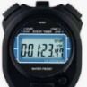
Have someone close by to help count, or use a timer on a watch or mobile phone.

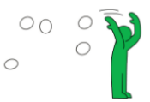
With 10 plates in each hand, throw all the paper plates up and
over your shoulder into the air, then start the clock.


See how quickly you can pick up all the plates.


Keep going to see if you can beat your time.

What is your quickest score today? Try again another day and see if you can get better over the week.

Skill Tip: Have ‘soft’ knees when bending down to pick up the plates, use your legs to do the work and keep the pressure off your lower back.
Challenges:
- Play the game again, this time, see how fast you collect all the plates and return over the finish line.
- Set up a finish line further away from where you threw the plates.
- Collect all the plates with only one hand

STEP
Space – Try sending the turtle from different levels by sitting, lying or kneeling.
Task – Do the run to the finish line facing backwards (carefully). Hop to collect the turtle.
Equipment – Smaller Turtle and less t shirts.
People – Ask someone nicely to help you with the cutting out. Play against someone to see who can hit the target first.

SPRING TERM HOME PE
Year 1
Yoga Poses Balance, strength skills
Equipment: A clear, safe, quiet place. Comfortable clothing
How to play:
Discover your inner yogi with some cool Yoga poses – Namaste!
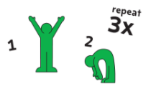
Get warmed up by raising your arms and stretching up to the sky
for a count of 10 seconds, then touch your toes for a count of 10.
Repeat 3 times.


Now make the ‘Butterfly pose’ by sitting and placing the soles of your feet against one another. Hold your feet for a count of 10 seconds. Repeat 3 times.


Next is the ‘Camel pose’! Kneel down, stretch your arms up over your head and reach back to your toes. Hold it for 10 seconds. Repeat 3 times.

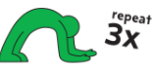
‘Dolphin pose’ is next – from standing, bend over and rest your elbows on the ground, keeping your legs straight. Tuck your head in and hold for 10 seconds. Repeat 3 times.


Finally, it's the ‘Tortoise pose’. Sit in a kneeling position, fold your body over and on to the floor, arms stretched out over your head. Hold for 30 seconds.

REPEAT THE CIRCUIT FOR 10 MINUTES.

Skill Tip: Make sure you warm up and create the poses slowly and smoothly.
Challenges:
- Try the poses again. See if you can feel even more balanced without wobbling.
- Try these with an adult and see if they’re as bendy and balanced as you?
- These poses are not a competition to see how quickly you can do them. Relax, be loose and feel yourself breathing nice and gently. Enjoy the quiet, peaceful time performing the poses.

STEP
Space - Try completing your stretches at different levels, standing and then lying down.
Task – Increase the time you spend on the poses or increase the repetitions.
Equipment – Balance a toy on your head, as you do the butterfly pose
People – Perform the poses with someone else. Why not make up your own?

SPRING TERM HOME PE
Year 1
Antique Shop Dash shuffling, balance, team work skills
Equipment: A medium size balloon + a partner if there’s someone handy
How to play:

Can you navigate the Antique shop without smashing the precious and valuable object?
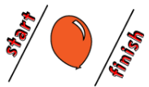
Grab a balloon and mark out a start line and a finish line.

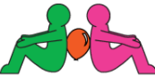
Sit back to back on the start line and carefully place the balloon
between your backs. Use a wall if you're by yourself.

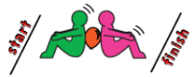
Shuffle to the finish line without dropping or bursting the balloon.

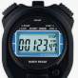
Think of different ways of holding the balloon between you.
Keep going until 10 minutes is up!

How long did you keep going before the balloon dropped today? Try again another day and see if you can go longer over the week.

Skill Tip: If you’re taking the challenge with a partner, work as a team. Can you communicate effectively to reach your shared goal?
Challenges:
- Play the game again. This time think of different ways of holding the balloon between you.
- If you’re playing your own, can you use different parts of your body to keep the balloon in contact with the wall? Travel with the balloon between your knees.
- If playing with a partner, take it in turns to “lead”. What skills are needed to “lead” your team? If you’re the team member, what skills do you need to be an effective team player?

STEP
Space – Change the space to be longer, or with a change of direction.
Task – Use different parts of your body to keep contact with the balloon, put a time limit on the game.
Equipment – Use balls of different sizes and weight, add obstacles.
People – On your own or with a partner. Race another pair.

SPRING TERM HOME PE
Year 1
Jungle Skills balance, changing direction skills
Equipment: Toys, cushions, hats, empty plastic bottles or similar for obstacles
How to play:

Can you make the moves to build your strength, agility and stamina? It's time to find your ROAR!
(Check out the play-along video).


To get started, build your course. Find 6 toys, cushions or hats and place them in a line with 2 steps between them.

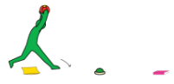
With a football in your hands, take big lunges forward over the toys and raise the ball above your head. Bring your feet back together and the ball to your chest and ROAR!

Next, rush through the Savanah - put the football down in front of your feet and test your agility
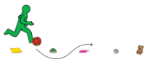
by dribbling the ball through the course.

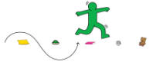
Keep going until the end of your course.

If you find it difficult, put the ball aside and dodge through the course instead.

Repeat this as many times as you can for 10 minutes to build up your stamina.

How long did you keep going for today? Try again another day and see if you can go for longer over the week.

Skill Tip: For your lunge, stand tall with feet hip-width apart. Step forward with one foot until your leg reaches a 90-degree angle. Press into right heel to drive back up to your upright position.
Challenges:
- Play the game again, and see how fast you can go through the obstacles there and back.
- Try with a friend and compare personal best times.
- When dribbling, try with you least favoured foot. If you’re right footed, try with your left.

STEP
Space – Make the track longer. Change the direction of your dribbling, forwards, backwards, sideways.
Task – Perform 3 star jumps at the first and last obstacle. Push the ball with your hands. Make up your own travelling game.
Equipment – Use different objects to dribble with - larger/smaller balls or maybe soft toys.
People – Time yourself against a friend. Find your personal best and try and to improve.
Video http://www.nhs.uk/10-minute-shake-up/shale-ups/simba-jungle-skills

SPRING TERM HOME PE
Year 1
WARTHOGS & HIPPO HOPS balance, strength, agility skills
Equipment: Soft Toys, cushions, clothes

How to play:

As a magnificent Warthog, imagine a tasty-looking insect has caught your eye… but it's on the other side of a mud hole full of sleeping hippos! Can you get through to the tasty snack without waking them?

Grab some cushions, clothes or even pieces of paper to be the hippos,
then lay them out across the floor. Make sure they're not too far apart.
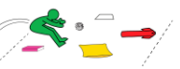
When you're ready, start your crossing!
Crouch down like a frog and leap over the first hippo.

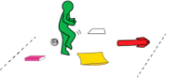
When you land back on the floor, keep hopping to stay out of the mud! Make your way across the mud hole, leapfrogging over the hippos until you reach the other side.

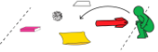
Once you've made it to the other side, turn around and cross back,
leapfrogging the hippos again. Keep going until the end of your course.

Keeping playing for 10 minutes.

What was your quickest crossing today? Try again another day and see if you can get quicker.

Skill Tip: Start in a standing position with your feet at shoulder width. Then lower down into a 3/4 squat position with your arms at your sides. Pause here for a second and get ready to jump up and forwards.
As you land back down, absorb the landing by bending your knees Keep eyes up and concentrate.
Challenges:
- Play the game again, and see if you can use fewer jumps.
- Try taking off and landing on one leg. Use the other leg if you get tired.
- Try with a friend. Who is the quickest? Who uses fewest jumps?

STEP
Space - Make the jumping space longer or shorter.
Task – Try other ways to get over – hopping, leaping, on your hands and feet.
Equipment – Move the objects higher or lower.
People –Time yourself against a friend. Find your personal best and try and beat it.

SPRING TERM HOME PE
Year 1
LIFT OFF! Strength and balance skills
Equipment: Two Toys for a start line and a tape measure

How to play:

Do you know how far you can jump? Take this challenge for one giant leap for mankind!
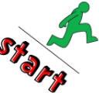
Mark out a start line jump as far as you can off the start line, and mark where you land.
If you do this with a friend, take it in turns.
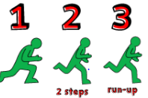

Now try again, but with a 2-step run up.

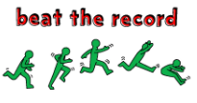
Keep going to see how far you can go!

How far did you jump today? Try again another day and see if you can jump further over the week.

Skill Tip: Your take off leg is the one that stays on the ground to support your weight when you kick a ball. Usually, if you are right-handed, your take off leg will be your left leg. When landing don’t fall backwards! Bring your heels up and your head down towards your knees. Every inch counts.
Challenges:
- Play the game again, and see how fast you can go through the obstacles there and back.
- Try with a friend and compare personal best times.

STEP
Space – Make a v shape using towels and start at the point of the v and jump over and see if you can work your way along to be able to jump from one side of the v to other. Make it wider to make it more difficult.
Task – Try different foot patterns: a two footed take-off and landing, one foot to two, hop, step and jump.
Equipment – Use markers on the floor to guide your hop, step jump. Use larger obstacles to jump over.
People – Make up your won jumping pattern and teach a friend.

SPRING TERM HOME PE
Year 1
Whizzy Speed Challenge Speed, agility, balance direction skills
Equipment: Toys, cushions to make a course

How to play:

How fast can you Whizz around the course?


Mark out a course with soft toys, cushions or some t-shirts.



At the start line shout GO! And run around the course.

If you do this with a friend once you complete the course, air high-five the next person, who then starts off around the course. How quickly can you get around the course?

Skill Tip: Be nice and balanced when you run around the corners. Stay on your toes.

How quickly can you complete the course? Try again another day and see if you can go for longer over the week.
Challenges:
- Run the course again, and do a star jump at each corner.
- Try with a friend and compare personal best times.
- Complete the course in the other direction.

STEP
Space – make the course shorter or longer. Change the direction and run forwards, backwards, sideways. Change the pathways of the course: straight, circular, wiggly.
Task – Change the rules, number of laps, how you travel, hop, skip, run, jump.
Equipment – Put in obstacles to make the course harder. Add markers and perform actions at the markers. Add a ball or rolled up socks and dribble round the course or throw and catch at the markers.
People – Do this with a friend and record your personal bests.

SPRING TERM HOME PE
Year 1
Keeeep Dancin’ - then Freeze! dancing, listening and balance skills
Equipment: Music player and someone to DJ

How to play:

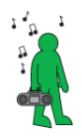

Find something to play music on and choose a DJ.

Start dancing and do your best moves! Whaahey!
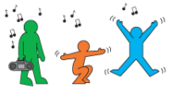

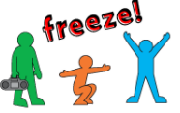

When the DJ stops the music, you must immediately freeze very, very still.

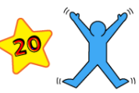
If you don't stop as soon as the music does, then you must do 20 star jumps to warm yourself back up and melt the ice!

How many times did you have to warm up today? Try again another day and see if you can stop to the music quicker and more often over the week.

Skill Tip: Concentrate and listen carefully to be ready to freeze! Tighten your muscles and have your feet spread apart for a better balance.
Challenges:
- Play the game again but travel high and low and have faster music.
- Try with a friend and compare the number of times you froze to the music.

STEP
Space – Use different levels, travel in different directions. Play in a larger space.
Task – Change the rules of when you are out: hop, hold a shape on hands and feet. Change the way you travel by skipping, jumping, or travelling on hands and feet.
Equipment – carry a toy or ball as you dance. Throw and catch the toy as you move.
People – enjoy dancing to the music with a friend or family member. Copy their movements.

SPRING TERM HOME PE
Year 1
Hopathon speed, balance, agility skills
Equipment: Cuddly toys + timing device (mobile phone/stop watch)

How to play:

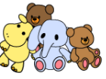
Mark out a start and finish line. At the finish line, make a pile of your favourite cuddly toys.

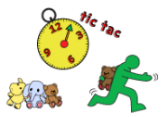

Start a stopwatch and hop from the start to the finish, pick up a
toy and hop back to the start.

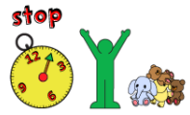

Keep going until all of the toys are on the start line, then stop the clock.

How quickly did you complete the challenge today? Try again another day and see if you can go quicker over the week.

Skill Tip: Take care when bending down to collect the soft toys. Bend your knees not your back.
Challenges:
- Play the game again, can you beat your best recorded time?
- Try with a friend and compare personal best times.
- Try carrying toys with you least favoured hand/arm. If you’re right handed, try with your left hand.

STEP
Space – change the pathway of the route, from straight to zig zag. Make the route longer or shorter.
Task –Add actions at the start and finish, like star jumps or hops. Change the way you travel, run backwards or skip.
Equipment – add heavier toys to make it harder, smaller softer toys to make it easier. Add obstacles to jump over.
People – Time yourself against a friend. Try a relay taking two alternate turns each.

