
SPRING TERM HOME PE
YR 2
Dock The Socks Sending and aiming skills
Equipment: 4 pairs of socks and a bin or target to throw into.
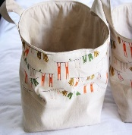
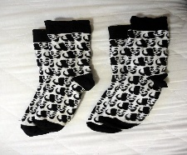
How to play:
This Photo by Unknown Author is licensed under CC BY-NC-ND

Place your target bin (saucepan, bucket, box) at the end of the room.

Start by taking one step back. Now throw your socks into the bucket underarm. Every time you get a sock in the bucket do two jumps to celebrate.

Pick up any that miss and try again. Once successful with one hand, do the same with your other hand.

Skill Tip: When throwing, if you use your right hand, step forwards onto your left foot. If you use your left hand, step forwards on your right foot. It helps you to balance and become more accurate.

Now play again by taking two steps back and if successful, increase the number of steps back.

What is your best score today? Try again another day and see if you can get better over the week.

Challenges:
- Play the game again, but this time can you throw the socks by starting with your arm above your head and throwing it downwards towards the bin. Be careful to send it gently so that the socks do not bounce out.
- Turn around and find a way of throwing the socks backwards, to land in the bin.
- Make up your own way of sending the socks and teach someone else your game.

STEP
Space - make the target bigger or smaller . Change the level of the target, have it on a table or a chair.
Task – stand on one leg or sit and role the socks into the target. Use your feet to kick the socks
Equipment – use a book as a racket and try and bat the socks into the target. Throw soft toys into the target or small counters.
People – Play against a friend. Have a goalkeeper trying to stop the socks going into the bin

SPRING TERM HOME PE
YR 2
Moving Maths Agility and balance skills
Equipment: indoor space

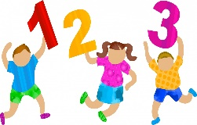
How to play:
This is a counting, moving activity. Do the following and count out loud each time you move:
- Walk forwards and count the steps from 0 – 50
- Walk backwards counting down from 50 – 0
- Two footed jumps forwards counting 0 – 20
This Photo by Unknown Author is licensed under CC BY-SA-NC
- Two footed jumps side to side counting backwards from 20 – 0
Skill Tip:
Remember to land lightly on your toes and look over your shoulder if you are jumping backwards.

- Take large giant steps forwards counting in 2’s …saying “2, 4, 6,” up to 20
- Do big steps backwards counting down from 20 – 0 in 2’s, saying “20, 18, 16 “
- Do little bounces on the spot and count to 50
- Do marching on the spot and count down from 50 – 0

Now we have done lots of counting whilst moving, we are now going to count and stay still as a statue.

- Balance with just your bottom on the floor, keep very still and count in 5’s up to 50
- Balance on your side and count in 5’s from 50 down to 0
- Balance on two hands, one foot and count in 10’s up to 100
- Balance on two feet, one hand and count down in 10’s from 100 to 0
- Balance on your tummy and count in 2’s up to 40
- Balance on your one foot and count in 2’s backwards from 40 to 0
Skill Tip: Remember when balancing, to keep your muscles tight and head still.
Challenge: Play moving maths by changing the actions to star jumps, skipping, or hopping. Play moving Maths with someone else and give them the instructions of how to move and how to count
STEP
Space - Change the distance you travel. Change the level – travel low on your hands and feet
Task – change the rules, try bunny hopping and counting. Change the counting to 5 times table.
Equipment – can you travel whilst catching, throwing or kicking a ball or soft toy.
People – Play follow the leader with a friend.

SPRING TERM HOME PE
YR 2
Scatter it. Sending skills
Equipment: 1 pair of socks or soft toy per person. Pack of cards or self - made numbers
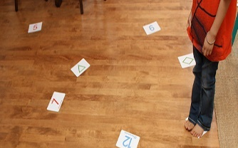
How to play:
Two players, each with a pair of socks, bean bag, or soft toy.

Scatter it Stand behind a line and take it in turns to throw the socks or soft toys. Throw the socks onto the numbers to score. Children can have a set number of goes and then add up their score.
Round the clock Mark number targets 1 – 12 and place on the ground. Take it in turns to land on 1 0’clock then 2, 3 and so on. First person to 12 o’clock wins.
Darts Scatter numbers all over the floor. Play first person to get to 50, by adding your scores.
Jump to it Lay the numbers on the floor. Take it in turns to throw your toy at a target. If you hit number 4, the other person must do 4 jumps. Change over.
High Steppers Take it in turns to throw your socks to hit a target. If you hit number 5, for example, the other person must do 5 high knee lifts on the spot, before their go.
Skill Tip: As you throw, swing your arm in a straight line and leave your arm and hand pointing towards the target.
Challenge: Start with a score of 100 and subtract the number you land on. First person to get to 0 wins.
STEP
Space - Change the distance you throw from. Make your target numbers larger or smaller.
Task – change the rules. Throw with your non dominant hand. Try batting the toys onto the targets. Do harder forfeits, like star jumps, skipping, hopping
Equipment – send smaller toys, heavier toys, have larger targets
People – Play in small teams 2 v2 or have a defender trying to stop you scoring.

SPRING TERM HOME PE
YR 2
Dance to it Moving to the rhythm
Equipment: Music with a clear beat.
How to play:

Put on a piece of music with a clear beat and you must keep moving till the music stops. Try the following:
This Photo by Unknown Author is licensed under CC BY-NC
- On the spot can you start by clapping in time to the music? Can you count up to 8 and keep repeating “1,2,3,4,5,6,7,8 as you clap.
- Keep clapping but can you now move your feet in time to the
music by marching on the spot.
- Once you can do that, can you start to walk around the space by clapping
and walking in time to the music
- Can you add a new movement on the 8th beat? Walk and clap, 1,2,3,4,5,6,7, and on the 8th beat you could add a jump. “1,2,3,4,5,6,7, jump,1,2,3,4,5,6,7, jump”.
- Now you can add new movements like a turn or heel flicks, side steps, knees up, spins. Can you do these in time to the music?
- Keep moving till the music finishes.
Body workout:
Put on your favourite piece of music and start by moving each part of your body:
Head Shoulders Arms Wrists Hips Knees Ankles Feet
Now you are going to be like Jo Wicks, making a workout activity for all your friends. Choose your song. Keep moving your body and make up activities that gets your friends moving their bodies, getting out of breath, but being careful and safe. Finish by doing slower movements, with some gentle stretches. Good Luck
Skill Tip Try and do each action for 8 beats, count the 8’s in your head as you are moving.
Challenge: Design a workout for the people in your home and get them to copy you. Video it and send to your friends.
STEP
Space - Change the levels you travel in , low on the floor , medium level on hands and feet . Change your pathways, in a circle, zig- zag, straight lines.
Task – change the actions from slow to fast, from strong to light.
Equipment – use different piece of music. Dance with a ribbon or toy in your hands.
People – dance beside another person, follow the leader or opposite.

SPRING TERM HOME PE
YR 2
Climb the Wall Problem solving, flexibility and balance
Equipment: lots of socks and gloves
How to Play:
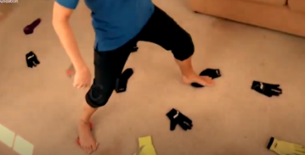
In this lesson, we are going to look at climbing which is linked to the outdoor adventurous activities section of the national curriculum. This isn’t vertical climbing, it's horizontal. There is no need for any specialist equipment you can do this indoors or outside and the only thing you need is socks and gloves.

Activity one
Lay your socks and gloves on the floor. To introduce the activity, we are going to do a warm up. All you have to do is use every sock as a steppingstone to get from one side of the room to the other. Progression This time, I am only allowed to use the brightly coloured socks and I can’t touch the black socks at all.
Activity 2
Now for the climbing. We are going to start using both the hand and the feet. When you are climbing, you ideally want to have four points of contact, two hands and two feet. Obviously, you need to move. So, as you are moving one part of your body, you want the other three anchored safely onto the floor, or on the wall if we were doing real climbing. Once you have mastered moving through the course on your hands and feet. Then we can add in some progressions to make things more difficult. To start with we can take out items - a sock here or a glove there, which means you will have to stretch further or even re-think your route through the course entirely.

1. No need to keep 3 points of contact 2. Put the socks and gloves closer together 3. Use more/ bigger socks and gloves – football socks, rubber gloves – to make it easier to balance Make it harder 1. Move socks and gloves further apart OR increase the distance to be travelled 2. Take some socks and gloves away 3. Ask a sibling to officiate and if any part of the hand or foot touches the floor you have to start again 4. As with the warmup, use only dark or bright socks and gloves
Challenge: You could introduce a time limit; can you get across the course before the buzzer goes off. To make it even harder you could introduce some obstacles. Put something like a cushion in the middle of the course that nobody can touch with any part of the body.

Space – Put the socks and gloves closer together. Move socks and gloves further apart or increase the distance to be travelled.
Task – you can only use the brightly coloured socks and gloves, choose a colour and only use that.
Equipment – use bigger socks and gloves to make it easier. Put obstacle in the way , cushions and toys that you must not touch.
People – ask a member of the family to officiate and if any part of the hand or foot touches the floor you have to start again.
Video Link to see the activity :
https://www.youtube.com/watch?v=jSP-fWmk36A&ab_channel=YorkshireSportFoundation

SPRING TERM HOME PE
YR 2
Balloon Volleyball Sending, attacking, and defending skills
Equipment: a balloon and something to make a net
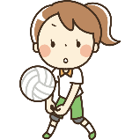
How to start:
First practice the skills you need for the game.
Have a balloon per player and practice keeping it ion the air above your head with your hands, whilst sitting on the floor. Make sure you always have your bottom, back or side always touching the floor. You can shuffle on your bottom and you can use your hands to help move, but you can’t stand up, go on your knees or leave the floor.
Scatter some cushions or targets on the floor and practice trying to get the balloon to land on them. Can you find the best way to get the balloon to travel quickly towards the targets?
Travel around the room on your bottom, using your hand to help you. Lie on your back and keep the balloon in the air. Lie on one side and keep the balloon in the air with one hand, change sides and try the other hand.
Practise Serving – throw the balloon up with one hand and then hit it over the net with the other.

Playing the game:
This Photo by Unknown Author is licensed under CC BY-SA
You will need a balloon. To make the net, draw a line on the floor using string or cushions or something long and straight in the house.
Players sit either side of the net. Practice sending the ball over the net and keeping it in the air. Players must always remain with one part of their side or back or bottom touching the floor, so they cannot kneel up, stand up or push up on their hands so that part of their body is touching the floor.
To play, one player starts with the balloon and serves it over the net, the receiving player must return the balloon back over the net without letting it touch the floor.
You may tap, push, hit the balloon back over the net, with any part of the body, but not catch it?
One point for the player who manages to outwit their opponent and get the balloon to land on their opponents’ floor.
You can shuffle to move around the court, and lay down to hit the ball, but not stand up. First player to 11 points, wins the game.

Skill Tip: Hit the balloon underneath to make it go up in the air , strike the balloon in the middle to make it go straight and hit the top of the balloon, if you want it to go straight down.
Challenge: Play the game, by making the net higher.
Space- make the court smaller or bigger
Task – change the rules of the game – allowed to catch and send back, allowed two taps before sending back
Equipment - make the net higher – tie the string around the leg of two chairs ?
People - Have more people in each team if you have more people at home ?

Video Use this link to see the game
https://youtu.be/sbEDyzsOBZk

SPRING TERM HOME PE
YR 2
Sweatshirt Agility Challenge Agility , balance and coordination skills
Equipment: A sweatshirt or jumper
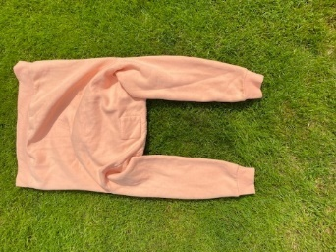
How to play:
It is important in any sport to be agile and fit. Footwork and ladder skills are a good way of improving your speed, strength, and agility.

Place a jumper on the floor like in the picture. Try the following footwork skills.
- Sideways 2 footed Jumps. Stand sideways beside the arm of the jumper at the top of the picture. Now jump sideways into the rectangle with two feet and sideways out of the arm of the jumper at the bottom of the picture. Having done 2 jumps to the left, now repeat two sideways jumps to the right. Keep going until you have completed 20 jumps.
- Forwards and backwards 2 footed jumps. Turn your body to face the arm of the jumper at the top of the picture. Jump forwards over both the arms of the jumper and then repeat by jumping backwards to the start. How quickly can you repeat the pattern until you have done 20 jumps?
- Side stepping alternate feet. Stand sideways to the arm of the jumper and step sideways over the arm so that both feet are in the middle, this is two steps. Now sidestep over the second arm so both feet are now out of the jumper. This is a four-step pattern. Can you repeat backwards and forwards until you have done 40 steps. Count out loud.
- Hopping sideways. stand sideways to the arm and try hopping on your left leg over both arms and then try hopping back on your right leg. Complete 20 hops.
- Hopping forwards and backwards. Stand facing the arm of the jumper and hop forwards over both arms and then try hopping backwards. Do 20 and then have a rest.
- Create your own. There are so many ways you can step, skip, hop, jump, using the jumper. Make up your own pattern and teach someone else in your home.
Skill tip : start of slowly and speed up once you feel confident.
Challenge: Place several jumpers in a row and do your pattern again to music. Keep going to the end of the song.
Space : Put several jumpers down in a row and complete a longer challenge
Task : Teach someone else your own pattern of footwork. Change the actions to hopping. Time yourself to get quicker. Increase the number of repetitions
Equipment : use other items of clothing to make a different agility circuit. Put it to music.
People : complete your pattern at the same time as a friend in unison. Race a partner.

Video : Click on the link to see another sweatshirt challenge. https://youtu.be/RLOMNM84Okg

SPRING TERM HOME PE
YR 2
Umbrella Golf Sending skills
Equipment: umbrella or club, a plastic cup, golf ball or rolled up piece of foil or paper. Tin cans.
How to play:
There are many games where you need to have good aiming skills. In golf you have putt the ball into a hole. The person who takes the least number of shots is the winner.
Rolling the ball
Place a plastic cup on its side, against a wall, with the open side facing out. Can you roll your paper ball or golf ball, into it? Practice rolling the ball from further away. Try rolling it with one hand and then the other. Have 10 goes and see how many times you get the ball in.

Putting the ball
Using the handle of the umbrella or a golf club, try putting the ball into the cup.
Have a competition with someone else and see who gets the ball into the cup the most times.

Keep in line Game
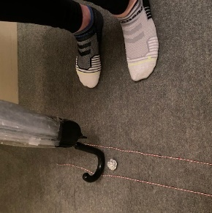
Make a track on the floor with two pieces of string or tape that is about 1m long. Can you putt the ball to stay in the track?

Skill tip: Stand sideways and have the ball in the middle of your feet. Keep your arms and wrists straight as you gently sweep the umbrella handle from side to side. You are trying to get the ball to stay inside the track.

Challenge: Make up a golf target scoring game, seeing how many shots it takes you to putt the ball into a plastic cup or towards a target.
Space : Put your target further away. Make you string track shorter or longer. Make it wider or thinner.
Task : set up a golf course in the room with 3 targets and see who takes the least number of shots. Play until someone has made 5 successful putts.
Equipment : Put several tin cans down on the floor in different parts of the room and try to hit them. Play with different sized golf balls or pieces of rolled up paper.
People : Play with someone else and see who is the first to make 10 successful putts.

SPRING TERM HOME PE
YR 2
Active Storytime Agility and balance skills
Equipment: Story Books
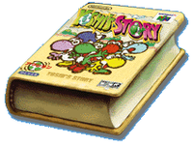
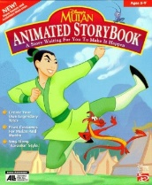
How to play:
- Moving your body to the story.
Choose your favourite story and read this by yourself or with someone else in the family. Every time you read a verb, perform the action together e.g. the dragon flew through the sky. How creative can you be with your movements? How do you fly ? How do you move your arms?
Verb= An action or doing word or feeling word e.g. jumped Adverb = A word that describes the verb e.g. quickly
Challenge yourself to find the adverbs and consider how to move e.g. The dragon flew gently .
Can you make up a moving imaginative sentence of your own?
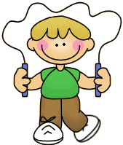
Synonym Skipping
Synonym : A word or phrase that means exactly nearly the same as another word or phrase. Play in pairs or as a family. Everyone needs a real or imaginary skipping rope. One person starts by shouting out an adjective (describing word e.g.small)
Everyone starts skipping or imaginary skipping and takes it in turns to shout out a synonym for the adjective e.g tiny, little, titchy . Person who cannot think of a word loses that game and you stop skipping. Play again, with a different word.
Skill Tip: If you are indoors, skip without a rope and keep light on your toes and swing your arms as though you have a rope.
Challenge: Play the skipping game using different themes; e.g football teams, numbers in the 6 x table, girls names, flowers, food.
Space : Move to the story in a bigger space. Skip on the spot or around the house.
Task : Change the movements in the skipping game, jump, hop, balance on hands and feet.
Equipment : Read different books, use music to skip to as you play the game.
People : Take it in turns to be the reader and the mover. Play with two or three people in the skipping game.

SPRING TERM HOME PE
YR 2
Cushion Tricks Gymnastics, balance and agility skills
Equipment: cushions or pillows and soft toys
How to play:
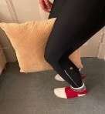
Cushion Run
With a cushion between your knees, set up a circuit around your home and see if you can walk around, keeping the cushion between your knees.
Now try running round the circuit. Finally jump around the circuit.
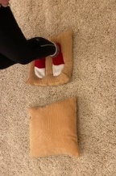
Skill tip ; keep your knees tightly together.
Cushion jump
You have two cushions. The game is to cross the length of your room by moving and jumping on the cushions. Your feet must not touch the floor. How quickly can you pick up and place the cushions to cross the room. Race a friend.
Cushion Rock
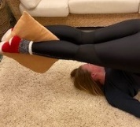
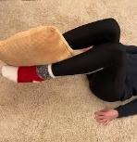
Lie on your back and have a cushion between your knees. Rock backwards and drop the cushion behind your head. Next try picking up your cushion with your feet and bringing it back over your head. Race a friend and see who can rock and drop and rock and pick up the cushion, the quickest.

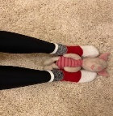
Toy drop
Lie on your back and place a cushion behind your head. Have a few soft toys by your feet. The game is to see how many soft toys you can pick up with your feet and rock back and place on the cushion behind your head. Try and place them carefully, so they stay on the cushion. Play against someone else in the house.
Challenge: Place four or five cushions across the floor. The challenge is to cross the room. You must travel on your hands and feet, but hands can only touch cushions and feet can only touch the floor.

Space : Travel in a larger space.
Task : Can you travel with the cushion between your ankles, your thighs. Make up your own rules.
Equipment : Try and drop smaller or larger soft toys.
People : Play against someone or teach another player a new cushion drop game.

