SPRING TERM HOME PE
YEAR 4
Battleships Aiming skills
Equipment: 6 Targets (Plastic Cups), rolled up socks or balls
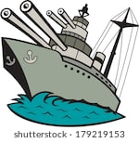
How to play:

- With a partner stand 5meters apart and have 3 targets (battleships) each and place them somewhere in front of you.

- Take it in turns to throw your socks/balls to try and hit each other’s battleship.

- Once a battleship is hit it is removed.

- Players cannot stop their battleship from being hit.

- The winner is the first person to hit all their partners’ battleships.

Challenges:
- Can you throw the ball a different way? If so did it make you more or less successful?
- Add some one target to become a barrier for one of your battleships.

Step:

Space- Make the Battleships either closer together or further apart to make it easier or harder.

Task- Step further away from the throwing line

Equipment- Change the targets so they are smaller to make it harder to hit

People- challenge someone different.

SPRING TERM HOME PE
YEAR 4

Noughts and Crosses Speed and Agility
Equipment: 9 Markers, 10 socks ( 2 groups of 5 colours)
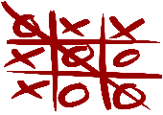
How to play:
This Photo by Unknown Author is licensed under CC BY-SA

- Put your Markers in a 3x3 grid, the same as if you were drawing noughts and crosses grid.

- Place the socks in two piles about 3meters away from the grid and split people into two teams

- One by one pick up a sock and run to the grid and place your sock on one of the markers.

- The first team to have three socks in a row wins.

Challenges:
- Can you change the way in which you travel to the grid?
- Try and come up with a plan with the rest of your group about which spaces you are trying to get your marker in.

Step:

Space- Place the start point closer or further away from the grid.

Task- Make the grid Bigger with more spaces, to make it a 4x4 grid.

Equipment- Before you can leave your area you must do an activity for example 5 Jumping Jacks.

People- Play against other members of your family and create a league.

SPRING TERM HOME PE
YR 4
Dice Balance Balance skills
Equipment: Dice or paper with 1-6 written of each. Safe Space
How to play:

- Roll the dice or pick a piece of paper and do a balance on the body part that corresponds with the number, see if you can hold the balance for 15 seconds.
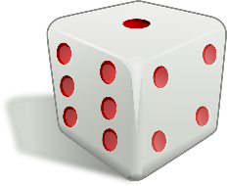
Number 1- Feet
Number 2- Stomach
Number 3- Bottom
Number 4- Knee
Number 5- Back
Number 6- Can you balance with 3 body Parts touching the floor
Challenges:
- Do it again but see if you can hold the balance for 30 seconds.
- Roll the dice three times and see if you can link the 3 balances together to create a little sequence.

Step:

Space- Make the space that you are using to balance on smaller to make it harder.

Task- make a whole sequence using all the balances that you have come up with.

Equipment- Use something that you have in the house or at school, for example a football, to try and balance with.

People- Balance with a partner or group.

SPRING TERM HOME PE
YR 4

Right Way Up Agility, Speed
Equipment: cones, Teddy Bears, Toys
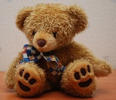
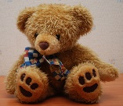
How to play:

- Spread all equipment in the area that you have making sure they are all upside down.

- On go run and see how long it takes you to put all the equipment the right way around.

- Once you have finished shout stop and look at the time.

- Do it again and see if you can beat your time.

- Game – One player has to turn the toys upside down and the other player had to put them the right way up. Make sure half are the right way and half upside down at the start and then on the word “go “ race for 30 seconds to see who can get the most .
Challenges:
- Only use your weaker hand or just your feet
- Before you turn the next piece of equipment over you must run back to the start.

Step:

Space- spread the equipment out.

Task- Instead of running is there another way you can move?

Equipment- Add three bits of equipment but if you touch these you get 2 seconds added to your end time.

People- Challenge people in your family.

SPRING TERM HOME PE
YR 4

Fitness Circuit Strength, Cardiovascular endurance (fitness)
Equipment: Space and timer
How to play:

Do each activity for 30 seconds with 15 seconds rest, if you can do it three times. You can do these in any order.
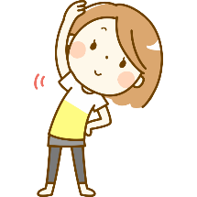
Burpees
Jog on Spot
Star Jumps
Plank
Sit Ups
Press Ups
Lunges
Lay on your back, lift your legs up slightly off the ground and hold
Squats
Heel Flicks

Make sure you have a minute rest before doing it again.
Challenges:
- On the third round do each activity for 45 seconds and only 10 seconds rest.
- Can you make up your own exercises?

Step:

Space- if you have more or outside run between two lines instead of on the spot

Task- Have a longer or shorter break if required

Equipment- add a weight, tin of beans to make the exercise harder.

People- challenge other members of your household.

SPRING TERM HOME PE
YR 4

Air Hockey Co-ordination and aiming
Equipment: small ball or a rolled up piece of paper and two towels
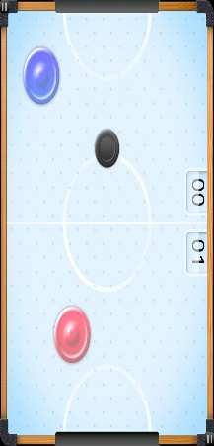
How to play:

- On a flat surface roll the towels up and pace then 1m apart to act as sides of a table. If you have a piece of paper scrunch it up

- Players go opposite one another at either end of the table.

- Use the ball or the paper as the puck

- Players use their hands to act as a bat and push the “puck” back and forth.

- Players score a point by pushing the puck past their opponent.

- The first player to 15 wins

Challenges:

- Add a plastic up which if your opponent hits off the table they win the game automatically.
- Only use your weaker hand.

Step:

Space- Make the towels wider apart so the table is bigger.

Task- Set yourself a time limit. Who can score the most points in one minute.

Equipment- Make the puck smaller or bigger to make it harder or easier to hit.

People- Challenge different people and keep a results table to see who wins overall.

SPRING TERM HOME PE
YEAR 4

Alphabet Scavenger hunt (outside or inside) stamina
Equipment: Paper and pen
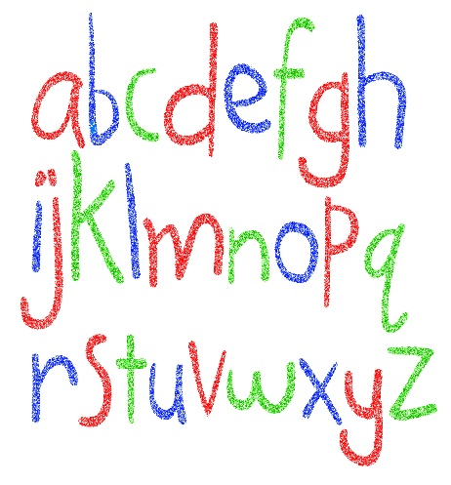
How to play:

- 2 or more players needed.

- All start in the same room on go run and find an object that begins with the letter A, run back to the starting point and write on your but if paper what you found.

- Continue until you have found all items for the whole Alphabet.

- The person who completes the alphabet first wins

Challenges:
- If you have 4 people or more create two groups and make it a relay, only one person from your group can be looking at a time.
- Get someone to say which room or area you are allowed to search in for each letter.

Step:

Space- Only use certain rooms or certain spaces within a room

Task- Give a set amount of time and see how many things you can see in that amount of time

Equipment- if outside collect the objects in a bag and create a poster.

People- Challenge different people

SPRING TERM HOME PE
YEAR 4
Minefield problem solving
Equipment: Tea towel/ blindfold and equipment for obstacles
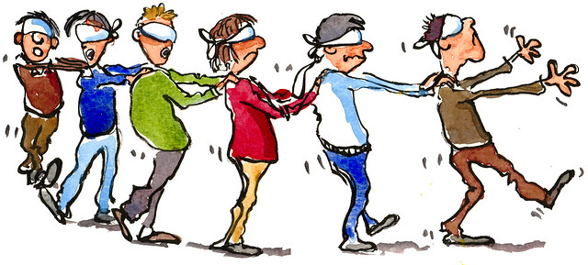
How to play:

- Set a start and finish space within this area put the different bits of equipment around ie cones, towels, chairs, balls.

- On person starts with the blindfold on and the other person directs them (no touching)

- If you hit a Mine (equipment) you must go back to the beginning.

- Time how long it takes you. Once you have been switch around.

- If there are more people see if you can beat each other.

NO PEEKING.

Challenges:
- Instead of using your voice to communicate come up with another way for example clapping.
- Place a certain object within the minefield that you must pick up on your way through.

Step:

Space- Make the equipment closer together to make it harder.

Task- Set yourself a time limit.

Equipment- choose equipment that is smaller

People- work with someone who you wouldn’t normally work with.

SPRING TERM HOME PE
YEAR 4

Cross the Swamp agility and balance
Equipment: 2 Pillows and 2 towels
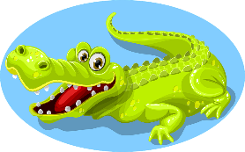
How to play:

- Roll up the towel and place each about 10 metres apart, between is the swamp.

- Start behind one towel and you need to make your way across the swamp only using the two pillows, if any part on body touches the swamp you must start back at the beginning.

Challenges:
- Time how long it takes you to complete it, challenge someone else.
- If there are more people see if you can do it with two people at the same time.

Step:

Space- Make the swap bigger by moving the towels further apart.

Task- Time yourself and either see if you can beat it the next time round or see if you can beat someone else.

Equipment- Have you got smaller pillows?

People- Try and include your whole family, you may need to add another pillow.

SPRING TERM HOME PE
YEAR 4

In the Box aiming and sending skills
Equipment: Box and Ball/ Socks
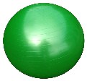

How to play:
This Photo by Unknown Author is licensed under CC BY-NC

- Place a box on the floor

- Start with being really close to the box and aim the ball/sock into it. Every time you get it on target you need to step back.

- See how far away from the box you can get.

Challenges:
- Have 5 tries at each distance.
- Add points system. If you get it very near the box you get 1 point, If you throw it into the box you get 5 points.

Step:

Space- Make your steps bigger to increase the aiming distance.

Task- Instead on throwing underarm can you throw over arm.

Equipment-. Make the box smaller or bigger to make it easier or harder

People- Challenge someone else to see who can score the most points.

