High Jump
Equipment:
A clear space free of hazards
Toilet rolls
How to play:

- Place a toilet roll on the floor

- Stand to in front of the toilet roll, using two feet jump over the toilet roll.

- Then add another toilet roll to the tower to create a bigger height.

- Keep adding toilet rolls each time.

- How many toilet rolls can you jump over?
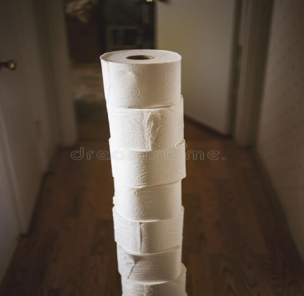
Top tips for jumping further - Keep your head up, swing your arms and lift your knees.

Challenges:

Keep practising to try and beat your highest score

STEP principle of coaching/teaching- helps to engage, challenge, and motivate everyone by altering one or more of the principles
Space – Ensure you have plenty of space to do the challenge
Task – The world record for men’s high jump is 2.45m how many toilet rolls is that the equivalent to?
Equipment – Try replacing toilet rolls with another pillows/cushions – how many can you safely jump over?
People - Have a competition against somebody else in your household. Who can jump over the most toilet rolls?

Video - https://www.youtube.com/watch?v=t8YN3hRLZrQ

Fancy Footwork
Equipment:

Something to step over some sort of marker, bottle, t-shirt rolled up.
How to play:

- Set out 2 markers
- Stand in between the two markers, then step with each outside foot outside the marker on each side in turn, going back to the middle each time.
- Try and do as many as you can in 1 minute

Have a few goes and see if you can beat your highest score.

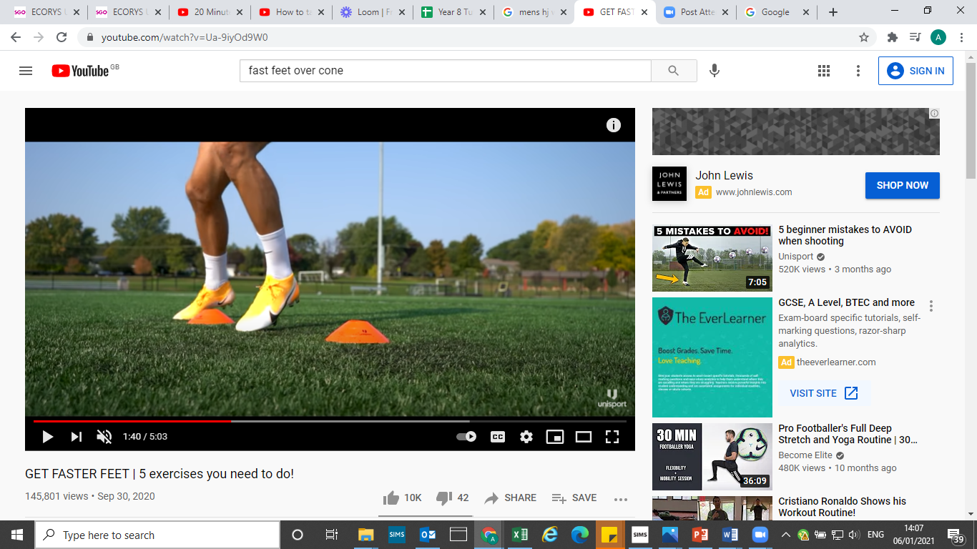
VIDEO: SKIP TO 1 MIN 34 SECS https://www.youtube.com/watch?v=Ua-9iyOd9W0

Challenge:

STEP principle of coaching/teaching- helps to engage, challenge and motivate everyone by altering one or more of the principles

Space - if the activity is too difficult, try and go a bit slower.
Task – See how many you can do in 2 minutes
Equipment – Add an additional marker using a household object. Can you now move between the three markers creating different patterns?
People – Get your family involved. See who can do the most. Race each other.

Bring Sally Up
Equipment: Song ‘Flower’ by Moby
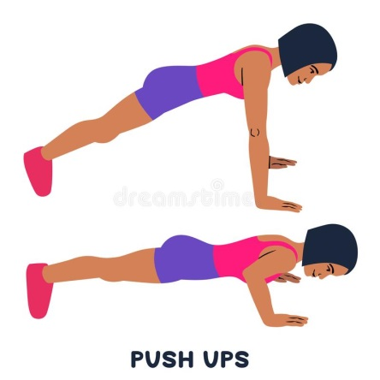
How to play:

- Play the song above.
- You have to hold the plank position, when the song says bring sally down you need to go down into a push up, hold it and then when it says bring sally up you go back up into a plank position. Keep going for the duration of the song, or as long as you can!
- Stop the time if your body touches the floor!

Challenge:

Can you keep going for the whole song?

STEP principle of coaching/teaching- helps to engage, challenge, and motivate everyone by altering one or more of the principles
Space - Plenty of space you are safe
Task – You can make this easier by doing the press up/plank on your knees.
Equipment – Maybe try placing a sock in between your shoulder blades. Can you keep this balance for the duration of the activity?
People – Do it with your family and see who can keep going for the longest!

VIDEO: https://www.youtube.com/watch?v=2Oe9PTp39Qo

Frying Pan Tennis
Equipment:
A frying pan, lots of pairs of rolled up socks, bucket/basket
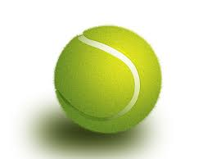
How to play:

- Place the basket 2m away.
- Using the frying pan hit as many pairs of socks directly into the basket as you can in 1 minute.


Challenge yourself with each try with an aim to beat your highest score.

If it is easy:

- Move the basket further away
- Try a forehand then a backhand
- Can you change hands?
Challenge:

Once you have had some practise of the first exercise, find someone in your household to have a rally with. Try and have the longest rally that you can between you without the socks touching the floor. If it does, go back to zero and start again.

STEP principle of coaching/teaching- helps to engage, challenge, and motivate everyone by altering one or more of the principles
Space - Make sure the space is big enough and clear of hazards. Stay close together initially, if you want to make it harder make the space you play in bigger.
Task – Split the middle of the playing area with a rolled-up towel, for example. Try and hit the socks hard enough so they do not land in your half of the playing area. If it does land in your opponents’ area you get the point. First one to ten wins.
Equipment – Try using 2 pairs of socks at one, each person starts with one pair (this is tricky) Use different sizes socks balls to see how that changes the challenge.
People – Keep challenging different players in your household, maybe you could create a competition to see who scores the most socks in the basket in 1 minute.

Toe Taps
Equipment:
A safe space, a ball, if you don’t have a ball use a rolled up t shirt or jumper.
Stopwatch
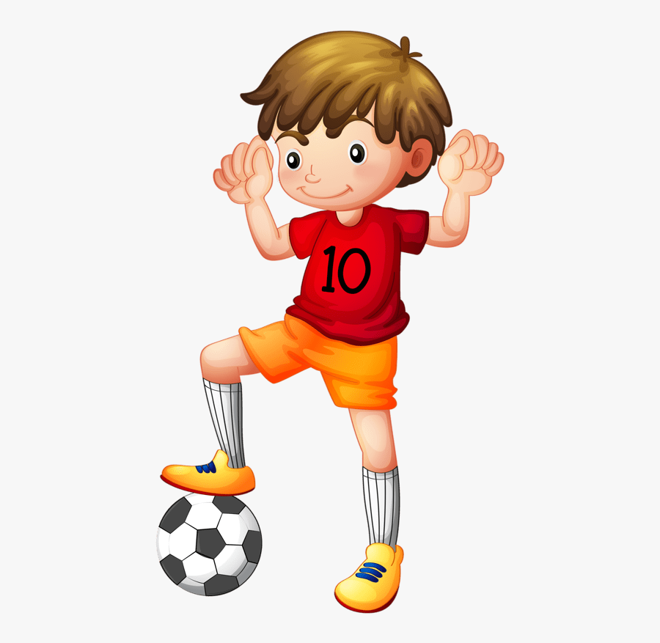
How to play:

- Place the ball on the floor in front of you

- The challenge is to tap your toe of each foot on the ball as many times are you can in 1 minute, 1 foot at a time.

Challenge:
Have a competition with yourself to try and beat your highest score.
Start off slowly, and then try and speed it up.

STEP principle of coaching/teaching- helps to engage, challenge, and motivate everyone by altering one or more of the principles

Space – Make sure you have plenty of space
Task – Try doing the challenge with your eyes closed? How does that change the task?
Equipment – Try focusing on an object in the room (at eye level). Try not to look at your ball.
People – Get more family members to join in – have a competition to see who can do the most toe taps.

Video - https://www.youtube.com/watch?v=kEMBXJ3qHvE

Juggling
Equipment:
A ball or anything that resembles a ball, bean bags, rolled up socks, anything that you can use to juggle that will not break if it is dropped on the floor, a clear and safe space.
How to play:
It takes lots of practise to be a good juggler, so stay focused:
https://www.youtube.com/watch?v=4DMbAMRI7fs
- Juggle with one ball – start throwing the ball from your left hand to your right hand and back again, try to throw smoothly and create an arc shape with your ‘ball’ in the air.
- Juggling with two balls – the second ball is thrown when the first ball reaches the top of the ‘juggling arc’.
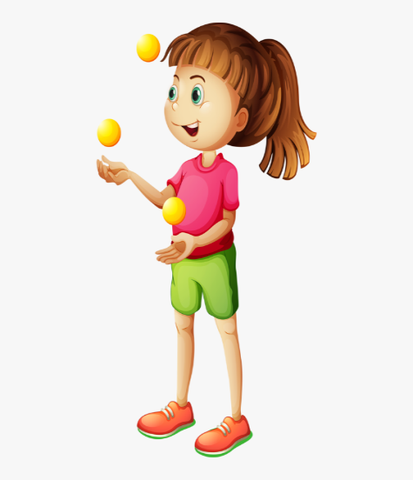
- Juggling with three balls – start with two balls in your left hand and one in the other. Throw the first ball from the left hand, when the first ball reaches the top of the juggling arc throw a ball from the right hand, and when the second ball reaches the top of the arc, throw the third ball from the left hand. Make sure you try and catch all the balls after you have thrown them!
Challenge:

How many throws can you do before you drop a ball?
STEP principle of coaching/teaching- helps to engage, challenge, and motivate everyone by altering one or more of the principles

Space - Use the space around you whilst juggling, you could even make the arc higher and wider
Task – Progress from one ball to two balls, then three balls. Try moving forwards or backwards or sideways whilst juggling. Attempt to beat your previous personal best score of ‘how many times I can juggle before dropping the ball’
Equipment – Use scrunched up bits of paper before progressing to socks and then balls (if you have them). You could even use balloons if you have them to make the task easier as they are slower moving in the air.
People – Play independently, play in pairs (one juggles, and one gives clear instructions to help), hold a conversation whilst juggling or try and sing a song! Have a competition against a partner or other members of your household.

Video - https://www.youtube.com/watch?v=fk4-wLZMPno

Home parkrun
Equipment:
Anything to make two markers on the floor
Stopwatch
How to play:

- Place two markers on the floor as far apart as you can but make sure you measure the distance between the markers (5m, 10m, 15m etc) – if you can go into the garden or outside it might be best. If not, find the biggest space in your house.


- Calculate how many shuttle runs it is to equal 2000m (junior parkrun distance)
- 5m = 400 runs
- 10m = 200 runs e.t.c.

- Use the stopwatch to time how long it takes you.

- Some of you may be used to doing the daily mile at school too, so you will be used to getting your daily walk/run.
Challenge:
Can you aim to keep moving for the whole time? 400 shuttle runs is a lot of runs, can you do it without stopping or walking? This may be something that you could practise every day and see if you can travel for longer each time without stopping.

STEP principle of coaching/teaching- helps to engage, challenge, and motivate everyone by altering one or more of the principles

Space – If possible, go for a walk/run outside with an adult.
Task – increase the speed of your running, do not stop, or take walking breaks.
Equipment – Place another marker in the middle of your course. Every time you pass this marker, can you do a mini jump?
People – Get more family members to join in, who can complete the junior parkrun the quickest? Could you complete it as a relay with you family members?

Video – https://www.youtube.com/watch?v=L6JZhQgp7KY

Speed Bounce Challenge
Equipment: A rolled up towel, a ruler, a long sock – anything flat that you can jump over.
How to play:

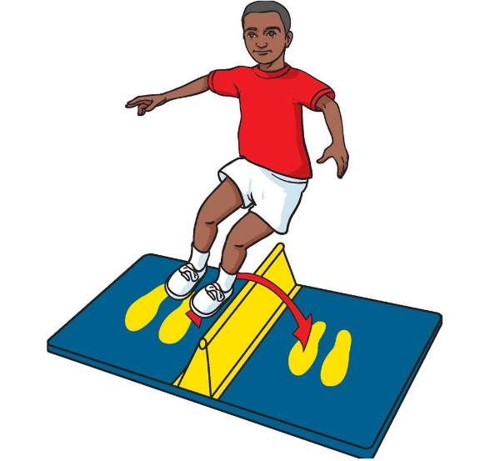
- Create a line on the floor using your equipment
- Keep two feet together, bend your knees and swing your arms to jump over the line you have created and back again. Remember to bend your knees when landing and try to land on the balls of your feet. Both feet must touch each side of the line at the same time. Each jump over the middle is worth one point.
- How many jumps can you achieve in 30 seconds? Have a few goes to get the highest score possible. What level below can you achieve?

Bronze – 10-20
Silver – 21-30
Gold – 31-40
Platinum – 41-50

Challenge:
Instead of a flat line, use something that is a raised. Use something that is sift so if you accidently stand on it you will not get injured. For example, a cushion/toilet roll. How many can you do in 30 seconds now?

STEP principle of coaching/teaching- helps to engage, challenge, and motivate everyone by altering one or more of the principles

Space - Stay close to the line/raised object to achieve your best score.
Task – Use a stepping action (instead of jumping with two feet) to make it easier.
Equipment – use higher objects to jump over the more confident you get.
People – Get more family members to join in- can you beat their score in 30 seconds?

Video
https://www.youtube.com/watch?v=gRRnI3vB1WI&list=PLYGRaluWWTojV3An2WEgsQ4qGFy_91jDL&index=13
Toilet Roll Towers
Equipment:
Toilet rolls x 3
Stopwatch
How to play:
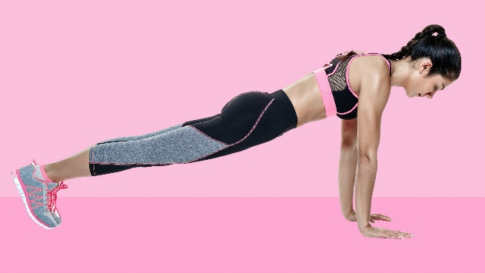
- Place the 3 toilet rolls in a tower in front of you to the left side.

- Get yourself into a plank position on your hands as shown in the picture.

- Whilst holding the plank move each toilet roll one at a time to form a tower on the other side. Once the tower is rebuilt, then again move each toilet roll back to the other side.

- Count how many complete towers you make in 1 minute.

Challenge:
Once you have linked three movements together, can you add more movements to your sequence by rolling the dice a further three times? Once you have linked 6 movements together, practise and perform your routine to another member of your household. Did you manage to complete the sequence without stopping?

STEP principle of coaching/teaching- helps to engage, challenge, and motivate everyone by altering one or more of the principles

Space – Make sure you have plenty of space around you.
Task – If you find the plank hard, you can do it on your knees to make it easier.
Equipment – Can you build bigger towers using 4 or 5 toilet rolls? How quickly can you re build them?
People – Change family members to see who can build the most towers.

VIDEO: https://www.youtube.com/watch?v=CxAOgSjScdQ

Alphabet Fitness
Equipment: n/a
How to play: Use the exercises below or choose your own.

Abdominal crunches
Burpees
Cycle Crunches
Dips
Elbow plank
Fast feet
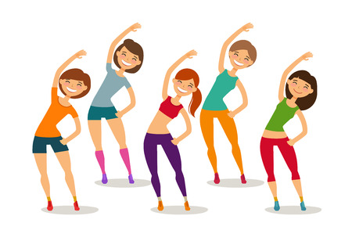
Goblet squat
High knees
Incline press up
Jumping jacks
Kettle bells
Lunges
Med ball
Narrow squat
Outer thigh raise
Press ups
Quick feet
Running
Step ups
Toe reach crunches
Upper cuts
V-sit
Wall sit
X-jacks
Y-lifts
Zig zag hops

Spell out your first name and surname – then complete 30 seconds of each exercise with 30 seconds rest in between

Challenge:
To make this more difficult spell out your name, middle name and surname.
Try 1 minute of each exercise with 30sec rest.
STEP principle of coaching/teaching- helps to engage, challenge, and motivate everyone by altering one or more of the principles
Space – Make sure you have plenty of space to complete the exercises.
Task – Spend longer on each exercise. Try spelling some different words to mix up the exercises.
Equipment – Try using some equipment in some of the exercises eg. Squat with tins of beans in your hands to make it more difficult.
People – Get your family involved and do the circuit together.

