SPRING TERM HOME PE
YEAR 6
Fill the Pot Sending skills
Equipment: 4 pairs of socks and a bin or target to throw into.

How to play:

- Place your target bin (saucepan, bucket or box) at the end of the room.

- Start by taking 10 steps back. Now throw your socks into the bucket underarm.

- Pick up any that miss and try again. Once successful with one hand, do the same with your other hand.

- Skill Tip: When throwing, if you use your right hand, step forwards onto your left foot. If you use your left hand, step forwards on your right foot. It helps you to balance and become more accurate.

- Now play again by taking two steps back and if successful, increase the number of steps back.

- What is your best score today? Try again another day and see if you can get better over the week.

Challenges:
- Play the game again, but this time can you throw or kick the socks and bounce it off a wall and get it to land in the pot
- Turn around and find a way of throwing the socks backwards, to land in the bin.
- Make up your own way of sending the socks and teach someone else your game.

STEP
Space - make the target bigger or smaller . Change the level of the target, have it on a table or a chair.
Task – place an object in the way of a straight throw to the target so you might have to go over it or find another way you can score. Use your feet to kick the socks. Try doing 2 kicks in the air before shooting at the target
Equipment – use a book as a racket and try and bat the socks into the target. Throw soft toys into the target or small counters.
People – Play against a friend. Have a goal keeper trying to stop the socks going into the bin

SPRING TERM HOME PE
YEAR 6
Gymnastics Balance and skills
Equipment: a Dice, floor/gym mat (or soft floor)
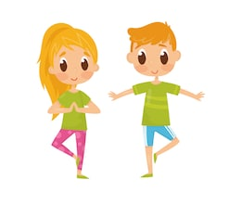
How to play:
How many different body parts can you balance on?
• Can you balance on your back and tummy? What do you do with you arms and legs?
• Can you balance on your hands and feet? Can you lift one hand or leg off the floor?
• Choose your favourite 3 balances.
Can you add them together to make a sequence. Perform your sequence to someone else. What do they think?

Dice Game
Use a dice to create a movement sequence.
• You are going to add 3 movements together.
• Roll the dice 3 times to see which 3 movements you will need to perform:
Roll a 1 = A star jump
Roll a 2 = A roll
Roll a 3 = A turn
Roll a 4 = A twist
Roll a 5 = A tuck jump
Roll a 6 = A balance
Challenge:
- Turn it into a memory game and see how many moves you can remember and repeat example: you roll a 1, so you do a star jump, you roll again and it is a 2 ,you perform a star jump first then a roll (1,2) you roll again and it’s a 6 you do moves 1,2 then 6 and keep rolling till you lose the order! Try to get up to remembering 8 moves.

- Play against someone in your household and take it in turns rolling the dice.

Space - perform your balance on different levels , High medium , low. Travel in different directions using different pathways
Task – Roll two dice at a time and link your actions or make your balances asymmetrical only or perform your movements by changing the speed or only have symmetrical arms in your balances.
Equipment – can you balance a soft toy on your leg as you balance. Perform your sequence in a straight line (use 2 pieces of string to make a straight line, like a bench)
People – perform the opposite actions to your friend or house member. If they balance high, you balance low, if they do a wide jump, you do a straight jump, if they travel high , you travel low.

SPRING TERM HOME PE
YEAR 6
Pillow Day Balancing skills
Equipment: at least 2 pillows, stopwatch/clock, plastic or small cups, Jugs and pint glasses
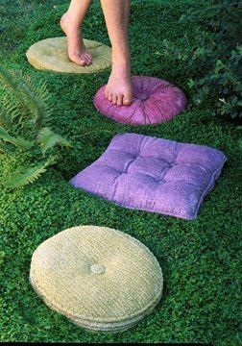
How to play:

The 10 minute pillow walk challenge
For 10 minutes you are only allowed to travel around the house stepping on pillows make sure you have 2 pillows to allow you to move around. Always stand on one and have 1 spare to place and step onto then pick the other pillow up and continue and see if you can last the 10 minutes!

Game
Pillow walk – place pillows around the room and you must move around the room by only standing on the pillows. Progress onto making a course and timing how quickly you can complete the course of pillows and then try again to see if you can beat your time.

Water race
Holding a plastic cup or a small cup place a jug full of water at the end of the course (Use a pint glass if you do not have a jug) and have another pint glass or jug next to you. You must use your plastic cup to scoop water out of the jug at the end of the room and bring it back to your own jug/ pint glass.

Make it easier or harder
Make it easier – put the pillows closer together so you do not have to travel as far
Make it harder – While going from pillow to pillow balance something on your head and see if you can complete the course without it falling off. Or just move the pillows further away!
Challenge:
- In the water race add pillows that you have to move along while holding your cup

Space - Move the pillows further or closer together
Task – Try hopping/ Hop scotching to pillows
Equipment – Balance something on your head while travelling to different pillows.
People – Race against a family member and see who completes the course the fastest

SPRING TERM HOME PE
YEAR 6
Wacky Weave Agility skills
Equipment: Set out cones—or canned goods, stuffed animals or whatever else you have on hand
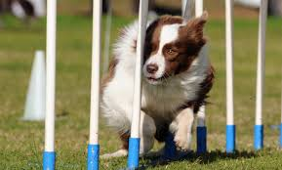
How to play:

- Create an obstacle course for children to weave their way through. The closer together you place the cans or cones, the harder it is; the farther you place them apart, the easier it becomes. Use a stopwatch to time your score then try to beat your time.

- Place cones or cans in a zig zag and you must get down low and move side to side to touch the cones or cans. Time how fast you can complete it. See if you can beat your time.

Challenge:
- Move the cones closer together so the gap is smaller
- Move the cones wider so you have to travel further on the zig zag
- Have a race against a family member
- See if you can complete it using a ball
Space - Move the cones or other objects further or closer together
Task – Change the course. Go in different directions adding forwards and backwards movements.
Equipment – Balance something on your head while completing the course. Use a ball to complete the course
People – Race against someone

SPRING TERM HOME PE
YEAR 6
The Challenge
Equipment: a small space and a stop watch
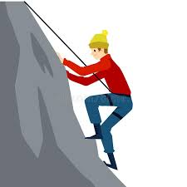
How to play:
You have 3 minutes to complete the circuit as many times as you can

10x Star jumps
10x Burpees
10x press ups
10x Squats

See how many times you can complete the circuit then try again later and try beat your time

10-1 work out! – see how long it takes you to complete!
10 x Burpees
9 x Tuck jumps
8 x Lunges
7 x Star jumps
6 x Press ups
5 x Touch your toes and jump up
4 x Sit ups
3 x Squats
2 minute run on the spot
1 minute plank

Challenge:
- Make your own 10-1 workout with exercises
- Challenge a family member to see who can complete the circuit the most in 3 minutes
- Complete your 10-1 workout with a family member
Space - set up stations to complete the task so you have to travel to the next station to do that workout
Task – Change the order of the 10-1 or make your own!
Equipment – try holding something while completing the work outs
People – compete against a family member or a friend on zoom

SPRING TERM HOME PE
YEAR 6
Connect
Equipment: A pen and paper, socks, soft toy and a bin
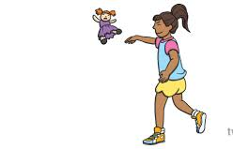
How to play:
Play on you own
- Write down 1-10 on a piece of paper
- Place the bin at the end of the room start taking big steps away from the bin, for every step you take away from the bin place a soft toy once you have done 10 steps stop.
- You start at the first soft toy (One step away from the bin) if you get it in the bin you put down an ‘S’ for score, if you miss from that one you put down an ‘M’ for miss, after each throw (even if you miss) you move back to the next toy. See how many ‘S’ and ‘M’ you have at the end and try beat it the next time round.

Playing in a pair
- Draw a four by four grid on your paper
- Players compete mini challenges against one another to win the chance to put their initial on the grid
- First player to connect 4 initials is the winner
- Pick your own challenges!
- Here are some if you are struggling for ideas:
- 10 star jumps or burpees
- Find something blue
- Best impression of an animal
- First to find an object
- Play hide and seek and time who finds who the fastest
- Flip a coin, one person is head the other is tails
- First to spell a word
- Who can balance on one leg the longest?
- First to throw a pair of socks and get it in the target wins
Challenge:
Be creative with your own challenges and have fun!

Space - make the target bigger or smaller . Change the level of the target, have it on a table or a chair.
Task – place an object in the way of a straight throw to the target so you might have to go over it or find another way you can score. Try shooting backwards. Change the challenges
Equipment – use a book as a racket and try and bat the socks into the target. Throw soft toys into the target or small counters.
People – play against a family member or a friend over z

SPRING TERM HOME PE
YEAR 6
Jumping Dice Gymnastics
Equipment: A Dice
How to play:
Play with a partner or on your own, take turns to roll a dice.
• Look at the number you have rolled and then complete the correct jumping exercises:
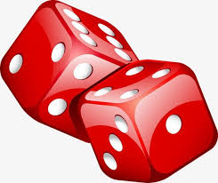
Roll a 1 = Perform 20 star jumps
Roll a 2 = Perform 20 tuck jumps
Roll a 3 = Perform 20 pencil jumps
Roll a 4 = Perform 20 jumps with a ½ turn
Roll a 5 = Perform 20 jumps with a full turn
Roll a 6 = Perform 20 squat jumps
• The first player to complete all the activities listed above is the winner or time yourself and see how long it takes you to roll all the numbers

Challenge:
Try and complete all the different tasks
Phone a friend! And play against them over the phone and see who wins!
Space - perform your Jump off of a different height maybe use a chair. Make sure you bend your knees on landing!
Task – Roll two dice at a time and link your jumps. Travel around the room using the jumps
Equipment – make a line of cones or soft toys and you have to jump to those toys
People – Play against a family member or a friend over zoom. Try to do the moves in sync with a family member or friend over zoom

SPRING TERM HOME PE
YEAR 6
Toy Collection Agility
Equipment: Toys, basket or cones, any items and stopwatch

How to play:
Play on your own
- Place 10 toys or items at the end of the room and set up a basket or a ‘base’ of where to start.
- Run and collect 1 toy at a time and bring it back to the basket/ start point, see how long it takes you to collect all 10 items, then try beat your time

With a friend or family member
- One person is calling out the amount of toys you need to collect (1-10) the other is the collector who collects the number of toys called by the other person.
- Make sure you are swapping with your partner.

Challenge:
Move further away from the toys so you must run further to collect them.

Add multiplication into the game for example 7x3 would mean collecting 7 items and leaving 3 and then answer the question of 7x3 which is 21, if they are correct, they get a point.
Space - move the toys further apart or you have to collect the toys in an order
Task – add in multiplication
Equipment – place the toys in different places, maybe put them up higher or lower
People – play against a friend or family member

SPRING TERM HOME PE
YEAR 6
Noughts and crosses Sending skills
Equipment: Balls of socks, 9 targets, paper and pen
How to play:
- Have a piece of paper and draw a 3x3 grid.
- Set out 9 objects in the same pattern as the 3x3 grid each target is equivalent to the grid
- Throw your socks and try hit a target. If you hit a target mark off on the sheet which target was hit. Example; if you hit the bottom left object then mark on the grid the bottom left box with either noughts or crosses (depending what you are) the first person to get 3 noughts or crosses in a row wins.
- If you miss the target you must do 10 star jumps, if you hit the target the other person does 10 star jumps
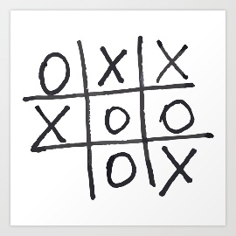
- Phone a friend if you need someone to play against!

Challenge:
- Balance on 1 leg and throw the socks
- Use your weak hand to throw the socks
- Come up with your own exercises to do for when you miss/hit the targets

Space - Move the objects further apart. Place the objects at different heights
Task – try throwing backwards or move further away from the objects
Equipment – have different sized targets and objects
People – play against a family member or friend over zoom.

SPRING TERM HOME PE
YEAR 6
Healthy Hearts Workout
Equipment: cones or markers
How to play:

- Layout 5 markers in a space around your area. These are your 5 cardio circuit activities.

  - Station 1: Perform 10 star jumps.
  - Station 2: Perform 10 mountain climbers.
  - Station 3: Skip or jump for 10 seconds.
  - Station 4: Perform 10 burpees.
  - Station 5: Jog on the spot for 10 seconds.

  - How many times can you repeat the circuit?

- Time yourself to see how fast you can complete it. Try beat your time next time.

- Play against a friend over the phone or a family member in the household.

Challenge:
- Set your own 5 stations and complete it yourself or against a family member
- Add in some equipment to make it harder to do the activities or try and keep something balanced while you do the activities
Space - Have them set up in stations further apart so you have to travel further
Task – Change the stations and add in your own workouts
Equipment – complete the tasks holding or balancing something
People – compete against a family member or work together to complete the tasks

