SPRING TERM HOME PE
YR 6
Kitchen Curling aiming and sending skills
Equipment:
A safe space, rolled-up pairs of socks, something to make a target with.
How to play:

Clear a space on a smooth surface i.e., a table or hallway floor and place a target at one end of the space.

Using a pair of rolled up socks, slide them across the floor, trying to get them as close to the target as possible.

Play against an opponent. Each player has three pairs of socks. The pair of socks closest to the target scores a point.

The player with the most points after three rounds is the winner.

Top Tip: Stiffen you hand to add power to your strike.
Challenge:
- Repeat the game, but place obstacles in the way of the target.

STEP principle of coaching/teaching- helps to engage, challenge, and motivate everyone by altering one or more of the principles

Space - Place the target marker closer to you. Only move it further away when you feel confident.
Task – add more obstacles in front of the target to make it more challenging. Try and hit the target in less than 3 throws. Can you play fairly and keep the score?
Equipment – Make the target marker bigger (to make it easier) or smaller (to make it more challenging).
People – Have a competition! Create a league table and play against different family members.

SPRING TERM HOME PE
YR 6
Table Tennis hand eye coordination
Equipment:
A small ball or rolled up piece of paper, books/cups to make a table tennis net, a table.
How to play:
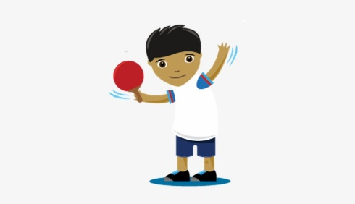
Use a table (outside or inside) and books or cups to create a net.

Using a small ball or rolled piece of paper, can you hit the ball/piece of paper, using your hand over the net and land it on your opponent’s side?

If you are using a ball, it cannot bounce more than once, if you are using a piece of rolled up paper it is not allowed to bounce.

The first player to score ten points is the winner.

Top Tip: Strike the ball low to high. Use the palm of your hand and hit the ball from underneath, pushing it up over the net low to high.
Challenge:
- Can you play fairly and keep the score?
- How long can you maintain a rally for (without having to stop the game)? Aim for 10 hits.

STEP principle of coaching/teaching- helps to engage, challenge, and motivate everyone by altering one or more of the principles
Space - Make sure the space is big enough and clear of hazards. Stay close together initially on a small table/area, if you want to make it harder make the space you play in bigger.
Task – Play for five minutes. The player with the most points at the end is the winner.
Equipment – If you are playing on your own - throw the ball against a wall. Let it bounce once and then catch it.
People – Keep challenging different players in your household, maybe you could create a tournament.

SPRING TERM HOME PE
YR 6
Indoor Scavenger Hunt problem solving and stamina
Equipment: Scavenger hunt list, something to time yourself with (optional)
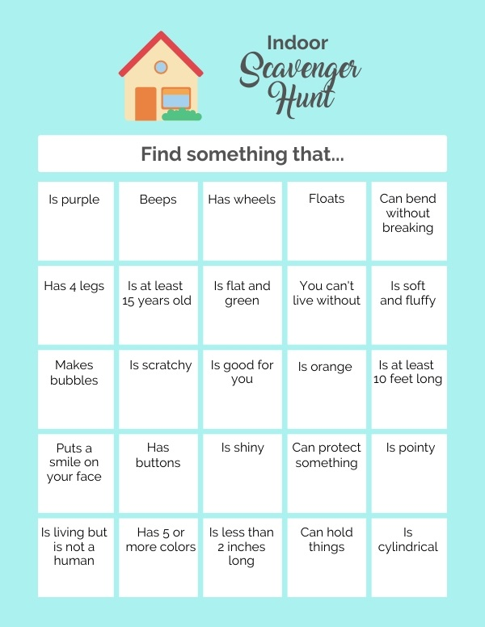
How to play:

Have a go at the indoor scavenger hunt -

Challenge:
Set yourself a time challenge – how quickly can you find everything on the list?
Could you create your own challenge and think of things for somebody else to find around the house?

STEP principle of coaching/teaching- helps to engage, challenge, and motivate everyone by altering one or more of the principles
Space - To make it easier/more difficult only use certain rooms within the house.
Task – Change the number of items to find (only find half of the items), create your own hunt indoors or if you can go outside, create one to take on a walk.
Equipment – Why not use a basket or the sofa as your treasure chest to collect your items in?
People – Play with someone else and have a race to collect all the items. If you create your own hunt, see how long it takes somebody to find the items on your list.

SPRING TERM HOME PE
YR 6
Fitness Challenge Stamina and strength
Equipment:
Something to time yourself with.
A safe space
How to play:

Have a go at these activities:

Stamina – Can you do 30 star jumps without stopping?

Speed – Can you run or do 10 jumps faster than an adult at home?

Core Stability & Strength – Can you hold the plank for 30 seconds?

Flexibility – Can you sit on the floor with your legs wide apart, how low can you get your chest to the floor?

Skill Tip: Complete each movement with quality, focussing carefully on the control of your body – even if you are tired!
Challenge:
- Can you create your own time challenge that works your: stamina, speed, core stability and strength and flexibility?

- Set yourself, or someone else the challenge and see if you/they can complete it.

STEP principle of coaching/teaching- helps to engage, challenge and motivate everyone by altering one or more of the principles

Space – You may have to adapt activities depending on how much space you have at home.
Task – Increase the number of jumps, star jumps etc if you find this easy or increase them to make it more difficult. Instead of thinking of one activity, think of 2 or 3 for each fitness component.
Equipment – Hold a toy or ball as you do the jumps.
People – Get more people involved. Could you have a competition against somebody at home?

SPRING TERM HOME PE
YR 6
Kidz Bop
Equipment:

A clear space free of hazards
An electronic device with access to the internet to watch and learn a new dance routine

How to play:

Watch this dance tutorial on YouTube (there are also many more to choose from in the link at the bottom of this page).

https://www.youtube.com/watch?v=Kd7ll_ZzfGw

Have a go at getting up and learning a new dance routine.

Challenges:

- Can you learn and remember the whole routine?

- Can you choose another song and choreograph something of your own? Aim for at least 30 seconds.

STEP principle of coaching/teaching- helps to engage, challenge, and motivate everyone by altering one or more of the principles
Space – You may have to adapt some of the movements depending on how much space you have.
Task – If this task is tricky, do not worry, it can be difficult to remember dance routines. Try and remember as much as you can or just dance along to the music. Can you create another routine on your own and remember all the movements? Could you get somebody to film you perform so you can watch yourself back? If so, write down or think of 2 things that you did well and 2 things that you could improve – keep practising to make the improvements.
Equipment – n/a
People – Could you teach someone else in your household the routine? Or get somebody to film you so you can watch it back.

Video – Link above plus lots more here https://www.youtube.com/hashtag/kidzbop

SPRING TERM HOME PE
YR 6
Keep on Moving Endurance skills
Equipment: 3 pairs of socks, 3 cushions and 3 toys
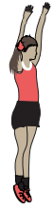
How to play:

Place 3 pairs of socks, 3 cushions and 3 toys in different places on the floor around your living space.
• Players move around the space in a creative way.
• When a player reaches a pair of socks, they jump 10 times. When a player reaches a cushion, they hop 10 times. When a player reaches a toy, they jog on the spot and count to 10.

Top Tips
Breathing - Make sure that you breathe in through your nose and out through your mouth when performing the activities.
Challenges:
- How fast can you complete the course? Time yourself and try and beat it
- Can you be creative and think of your own movement ideas

STEP
Space - move the equipment further away or closer together. Can you move at different levels?
Task – Change the activity you do on each of the pieces of equipment, maybe instead of jumps you do star jumps
Equipment – Can you add more of each piece of equipment?
People – Compete against a friend or family member.

SPRING TERM HOME PE
YR 6
Dodge the Defender Agility + Catching skills
Equipment: A chair, a ball (or pair of socks)
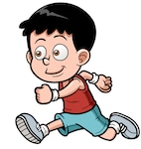
How to play:
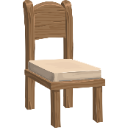
- Imagine the chair is a defender that you need to move around. Keep facing forwards as you move your feet around the chair. Work for 20 seconds in one direction and then 20 seconds in the other
direction. Repeat 3 times

- With a family member or friend, move around the chair for 30 seconds but change direction when your family member or friend calls ‘change’.

- Add in a ball. Either throw the ball around the chair by yourself and move your feet to collect it or have someone else throw the ball to space around the chair for you to collect.

- Work for 10 throws then rest and repeat 4 times.

Skill Tip: Stay on your toes and keep your body facing the direction you travel in.
Challenge:
- When you throw the ball up can you get around the chair and catch it before it falls onto the floor
- See how many times you can get around the chair before you catch the ball

Space - Can you get lower to the floor and move around the chair? Add in another chair to increase the distance covered.
Task – Throw the ball up and try get around the chair as many times as you can before you catch it.
Equipment – use different sized equipment to test yourself maybe get a smaller toy or larger toy to catch.
People – have your family member throw the ball for you. Challenge a friend to see who can get around the chair the most in 1 minute.

SPRING TERM HOME PE
YR 6
Plank shooting Strength skills
Equipment: a ball and 2-4 objects (to make a goal)
How to play:
If playing on your own
Place two objects at the end of the room to be a goal and have starting/shooting position 5 steps away from the goal.
- You must hold the plank position throughout
- Rolling the ball from the shooting position try and score a goal. Remember you still must be holding plank!
- Collect your ball and repeat.
- See how many goals you can score before you cannot hold plank anymore!
Playing against someone
Make sure you have a goal each
- You must hold the plank position throughout
- You score by rolling the ball through your opponents goal
- Two points are awarded if the opponent drops from the plank position 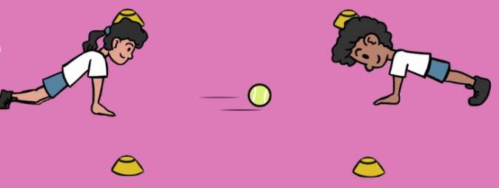

Skill Tip: Keep your hands flat on the floor when holding the plank position.

Challenge: See how many goals you can score in 1 minute.
Space - Move the goals closer together or further apart.
Task – Try rolling the ball to score with your weaker hand.
Equipment – Make the goal smaller or bigger.
People – Play against someone to see who scores the most goals.

SPRING TERM HOME PE
YR 6
Battleships Throwing and accuracy skills
Equipment: ball (or a Pair of socks) any objects

How to play:
With a partner
With a partner, each player places three targets (battleships) in front of them.
• Players take turns to throw an object towards their opponent’s battleships.
• Each time a battleship is hit, it is removed.
• Players are not allowed to stop the object from hitting a battleship.
• The winner is the first player to hit all their partner’s battleships.
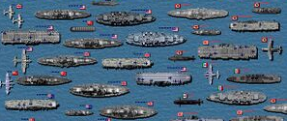
On you own
Place three targets (battleships) in front of you
See how fast you can hit the 3 targets

Top Tips: Throwing Underarm
Step forwards with one foot, releasing the ball from low to high using your opposite hand
Challenge: See if you can bounce the ball off a wall to hit the targets.

Space - move closer or further away from the objects.
Task – try bouncing the ball off the wall to hit the targets.
Equipment – Add more targets to hit. Add smaller targets and have a smaller ball.
People – play against a family member or race against a friend.

SPRING TERM HOME PE
YR 6
Ship Shape Gymnastics balance, agility , flexibility
Equipment: Space
How to play:
Can you create the following balanced shapes?
• A ‘wide’ shape. Are you high or low, what body parts are you using?

• A ‘curled’ shape. Are you high or low, what body parts are you using?

• A ‘narrow’ shape. Are you high or low, what body parts are you using?

• Can you teach someone else all your different balanced shapes?

• Can you create a sequence of all 3 balanced shapes together?

Top Tips: Be Still!
All balances must be held completely still for at least 4 seconds. Make your balances excellent by pointing your fingers and toes.
Challenge:

Increase the number of moves in your sequence and link together.

Can you do 3 balances, 3 jumps and 3 turns?

Space - try doing your balance from different levels, high, medium, and low. Make different shapes in space with your arms and legs.
Task – Do as many shapes as you can in 30 seconds. Make asymmetrical balances, do symmetrical jumps.
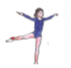
Equipment – try balancing a soft toy or bean on your body while you do the shapes. Put your sequence to music.
People – Challenge your family member or friends to copy you, or you copy them.

