

SPRING TERM HOME PE - YR 5
3 minute challenge Fitness skills
Equipment: Stopwatch
How to play:

Time yourself for 3 minutes. How many times can you complete this circuit?

10 x Star Jumps
10 x Squats
10 x Burpees
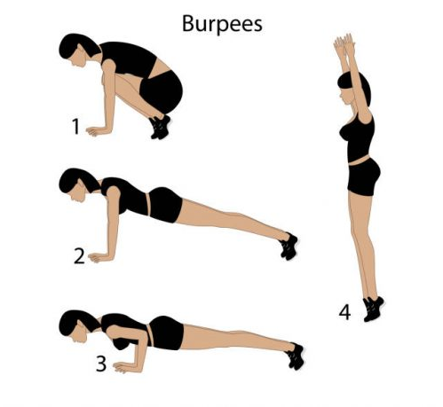
10 x Sit ups
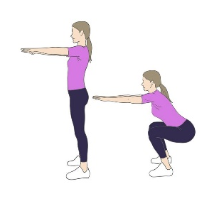
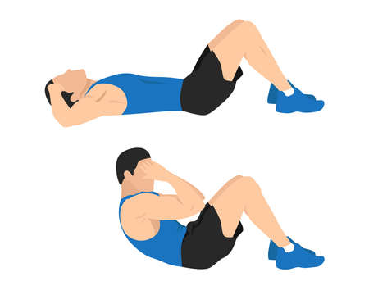
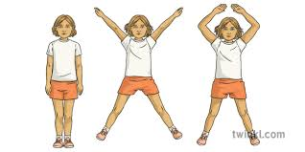

Challenges:

- Try the circuit again later – how many more activities can you complete in the same time?
- Add in press ups as an extra activity – can you still complete the same number of circuits as before?

STEP
Space -
Task – Increase the time – how many can you do in 4 minutes?
Equipment – Hold 2 cans of baked beans while you do the squats
People – Work with a partner in your home to challenge each other. If you don’t have space to work at the same time, take turns and count for each other.

SPRING TERM HOME PE - YR 5
London stairs challenge! Fitness
Equipment: Stairs!
How to play:

Can you climb one of these famous buildings in London?

There are many tall buildings in London. Choose one of these and climb your stairs once per floor until you have climbed to the top of your building! E.g. to climb the Gherkin, you will need to go up your stairs 41 times.


If you don’t have stairs at home, could you use a step (e.g. doorstep) instead? An average flight of stairs has between 10 and 13 steps, so you’ll need to do about 10 step ups for each flight of stairs you want to climb.


The Gherkin – 41 floors
Skill tip:
22 Bishopsgate – 62 floors
The Shard – 87 floors

Be careful on the stairs! (don’t run down them, even if you run up!)

Challenges:

- Get someone to time you – how quickly can you complete the task?
- The Shard is the tallest building in the UK. Can you find a taller building somewhere else in the world and climb that?

SPRING TERM HOME PE - Year 5
Fast feet! - improve your fast twitch muscles in your legs
Equipment: 3 toilet rolls /or a pillow
How to play:

Clear your space in your room so that you have 3 new toilet rolls standing up next to one another and a stopwatch.

Start your stopwatch and start jumping with 2 feet over the three toilet rolls as quicky as you can – count how many you can achieve in 30 seconds. Record your score on your paper. When you do this look down at the toilet rolls to ensure that you don’t jump too wide but get both feet over the toilet rolls or the pillow!

Have a second go. Does your score improve?
Try again another day and see if you can get better over the week.
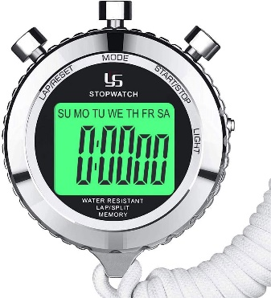
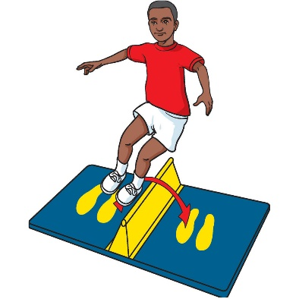

Make this with 3 toilet rolls lined up

Challenges:
- Can you do 40 seconds?
- Time yourself to reach a target number for example can you achieve 60 jumps – how long does it take?

STEP
Space - make the target bigger or smaller use 4 toilet rolls and stack them 2 on 2.
Task –can you work for longer?
Equipment – use a pillow (this is much more challenging).
People – see if you can ask someone in the house to have a go.

SPRING TERM HOME PE – YEAR 5

Target throw - improve your aim – let’s hit the target!
Equipment: 4 pairs of socks and a bin or target to hit
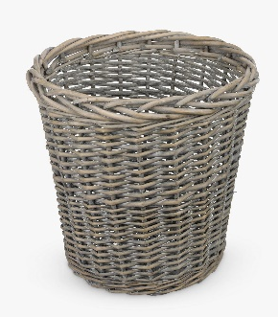
How to play:

Roll up a pair of socks into a tight ball. Do this with 4 pairs of socks. Go and get a bin or select a teddy/something you can use as a target.
Get a throwing line and then take 5 large steps where you place your bin/target.
Return to the start line.
Throw underarm your first pair of socks. How close were you to the target? Compete all 4 throws.

Award yourself your point system - 5 points if it goes in, 3 points if it touches the target, 1 point if you are close.

Have 4 rounds. Each round write down your points. How many did you score?

Skill Tip:
Look closely at your target. Throw the sock with an underarm throw.

Challenges:
- Can you move your target further back and still score as many points?
- Make your target smaller – can you still score?

Space - Can you place the target further away
Task –can you see how many you can achieve in 30 seconds by running to collect your socks and running back to the start line.
Equipment – make the target smaller.
People – see if you can ask someone in the house to have a go and compete against them.

SPRING TERM HOME PE – YEAR 5
Complete the clock Football skills
Equipment: Ball, 12 markers (e.g. rolled up socks), stopwatch
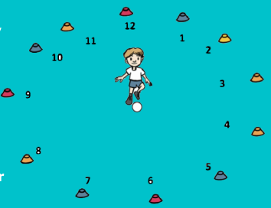
How to play:

Make a circle with the markers – imagine what the numbers of a clock would look like and put one marker where each number would be.

Stand in the middle. Kick your ball through each of the gaps in turn, until you are back at the start.

Skill tip:

Use the inside of your foot to kick the ball.

Challenges:

- Get someone to time you – how quickly can you complete the clock?
- Pass the ball once through 1 o’clock, twice through 2 o’clock, 3 times through 3 o’clock etc

STEP
Space - Place the markers further out or closer in to the middle.
Task – Pass the ball once through 1 o’clock, twice through 2 o’clock, 3 times through 3 o’clock etc up to 12 times through 12 o’clock.
Equipment – Instead of kicking the ball, throw it to a partner to practise your netball skills. Change the ball to a smaller one (e.g. a tennis ball) and throw and catch it.
People – Play with someone else – get them to stand outside the markers and stop the ball, control it and pass it back to you each time. They then move round the circle. Swap over with them.

SPRING TERM HOME PE – YEAR 5
Speed challenge! how many spots can you mark on the paper on each chair in a minute?
Equipment: 2 pieces of paper/2 chairs/a coloured pen – a space that allows you to have the chairs 3 wide steps apart and a stopwatch!
How to play:
Place a piece of paper on each chair then put them 3 very wide steps (3metres apart).

Start the timer for 30 seconds. Run from one chair to the other with a coloured pen in your hand. Each time you get to a chair mark down a spot on the paper. Return to the other chair and mark a spot on the paper. Repeat this until the 30 seconds are up.
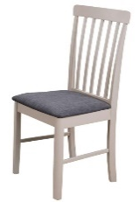
Count your spots on both pieces of paper.
3 wide steps apart

What running technique did you use? Did you use
side steps that were small and fast?
Did you move the pen from one hand to the other?

Repeat the challenge – turn the paper over to have another go.

Tip:
- As you become more confident changing your hand to mark the paper your score will improve which will improve your number marked down.
- Try not to cross your feet over in front of one another.
- Take small fast steps that shuffle quickly.

Challenge:
Space - Can you move the chairs further apart to make you run a little further?
Task –can you see how many you can achieve in 1minute 15 seconds?
Equipment – make the paper go on the floor rather than on a chair so you need to bend down on the floor to make it much more difficult.
People – see if you can ask someone in the house to have a go.



Uttlesford School Sport Partnership

SPRING TERM HOME PE – YEAR 5
Loggers Agility and communication skills
Equipment: Game for 2 players; 2 pool noodles or 2 sheets / towels rolled up into a sausage shape; a large cuddly toy or ball; and a bin or target to aim for.
How to play:

Using your pool noodles or large sheets rolled into sausage shapes, you hold one end in each hand and your partner stands opposite (facing you) and does the same. Working together the aim of the game is to lift the large object off the floor, transport it across the room before trying to ‘drop’ it into the target area (bin) at the other end of the room.

Every time you are successful, return to the starting point and try with a different object. Try and pick up any that fall out along the way.

Skill Tip: Work together as a team. Communicate with your partner what you are trying to do and listen to their ideas. Try walking sideways like a crab when you have the object raised from the floor. If you are finding the task too tricky, then hold the pool noodles (rolled sheets/towels) closer to the middle.

What was the trickiest object that you lifted today? Why was it so difficult? Try again another day and see if you can get better over the week.

Challenges:
- Play the game again, but this time can you race against the clock? How many objects can you successfully deliver in 30 seconds?
- One of you turn around and face away from your partner (with your hands now behind your back) can you still pick up and drop the object into the target area?
- Thread a coat hanger through one of the pool noodles (rolled sheet / towel) and use the hook to lift the objects.
- Place the starting objects in different places and /or on different levels (i.e. on a chair, on a table, under a table…).
STEP
Space – Make the target area bigger or smaller. Change the level of the target, have it on a table or a chair.
Task – Use longer or shorter rolled sheets. Vary the size of the objects you are trying to carry.
Equipment – Add straight and sturdy objects inside the rolled sheets to make them more stable. (For example: you could use broom handles, a garden cane or an umbrella)
People – Play with or against different family members.

Video https://www.youtube.com/watch?v=qCQ7BcTG4yQ (from 3.29)

SPRING TERM HOME PE – YEAR 5
Gymnastics Balance and gymnastics skills
Equipment: a dice, floor/gym mat (or soft floor)
How to play:
1
How many different body parts can you balance on?
• Can you balance on your back and tummy? What do you do with your arms and legs?
• Can you balance on your hands and feet? Can you lift one hand or leg off the floor?
• Choose your favourite 3 balances.
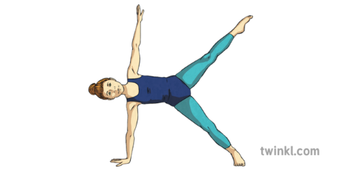
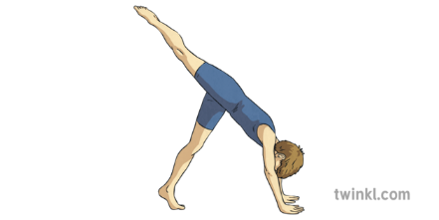
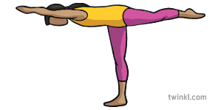

Can you add them together to make a sequence? Perform your sequence to someone else. What do they think?
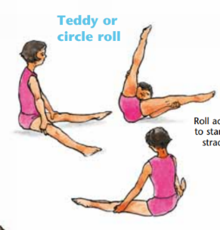
2
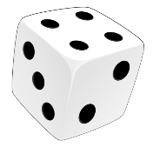
Dice Game
Use a dice to create a movement sequence.
• You are going to add 3 movements together.
• Roll the dice 3 times to see which 3 movements
you will need to perform:
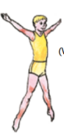
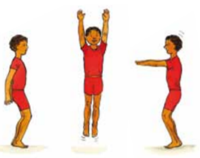
Roll a 1 = A roll
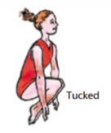
Roll a 2 = A turn
Roll a 3 = A star jump
Roll a 4 = A twist
Roll a 5 = A balance
Roll a 6 = A tuck jump

Challenge:
- Turn it into a memory game and see how many moves you can remember and repeat example: you roll a 3 so you do a star jump, you roll again and it’s a 1 you perform a star jump first then a roll (3,1) you roll again and it’s a 6 you do moves 3,1 then 6 and keep rolling till you lose the order! Try and get up to remembering 8 moves.

- Play against someone in your household and take it in turns rolling the dice.

SPRING TERM HOME PE – YEAR 5

Noughts and crosses Sending skills
Equipment: Balls of rolled up socks, 9 targets, paper and pen
How to play:
Have a piece of paper and draw a 3x3 grid.

Set out 9 objects in the same pattern as the 3x3 grid each target is equivalent to the grid
Throw your socks and try to hit a target, if you hit a target mark off on the sheet which target was hit.

Example; if you hit the bottom left object then mark on the grid the bottom left box with either noughts or crosses (Depending what you are) the first person to get 3 noughts or crosses in a row wins.
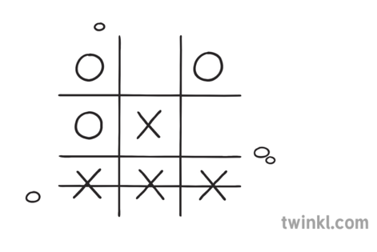

If you miss the target you must do 10 star jumps, if you hit the target the other person does 10 star jumps

Phone a friend if you need someone to play against!

Challenge:
- Balance on 1 leg and throw the socks
- Use your weaker hand to throw the socks
- Come up with your own exercises to do for when you miss/hit the targets

SPRING TERM HOME PE – YEAR 5

Mobile phone fitness fun! Fitness skills
Equipment: skipping rope
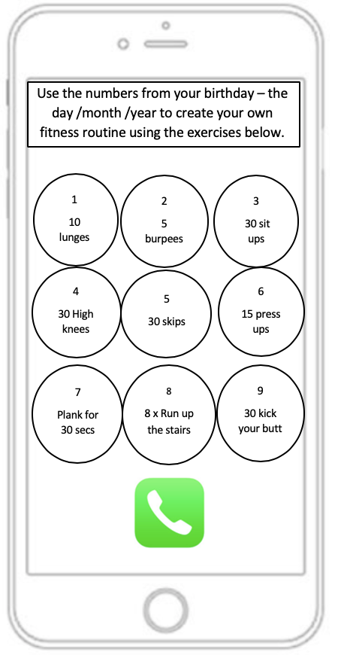
How to play:

Use the numbers from your date of birth to create your own fitness routine using the exercises shown on the mobile phone.

e.g. 28th December 2013 would give you:

2 – 5 burpees
1
2
3
8 – 8 x run up stairs
1 – 10 lunges
2 – 5 burpees
2 – 5 burpees
0 – 10 squats
4
5
6
1 – 10 lunges
3 – 30 sit ups

0
9
8
7
10 squats
Challenges:
- Use someone else’s date of birth to create a different routine of exercises – e.g. a parent, a grandparent, a friend.
- Use a different type of number e.g. a phone number
- Work with someone else to ‘call’ each other – you do their phone number and they do yours! You could do this with a friend in their own home.

